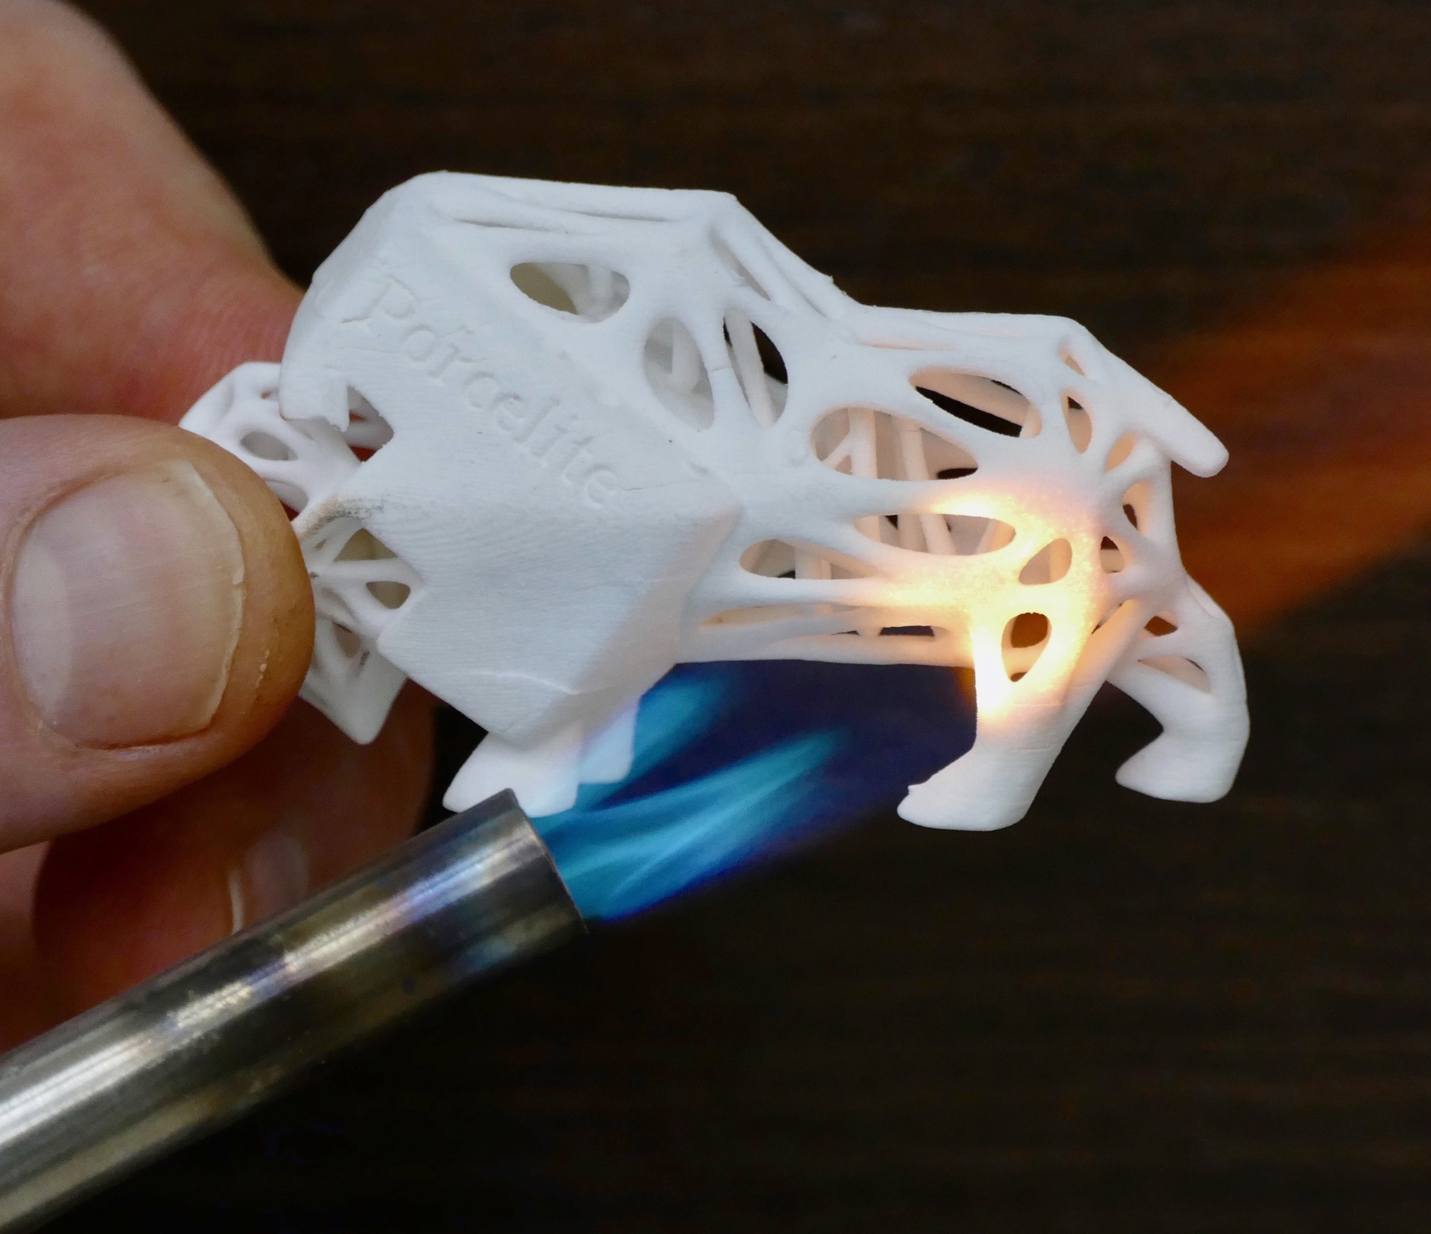
Porcelite®
Porcelite®
Porcelite® is a UV-curable porcelain resin suitable for 3D printers that utilize SLA, DLP or CLIP technologies with UV wavelengths between 350 - 405 nM.

Porcelite is ideal for objects requiring high resolution details. It’s capable of printing at 25 micron layer thickness.

After firing, objects may be glazed with commercially available glazes. Glazed objects are food safe, microwave, oven, dishwasher and freezer safe.

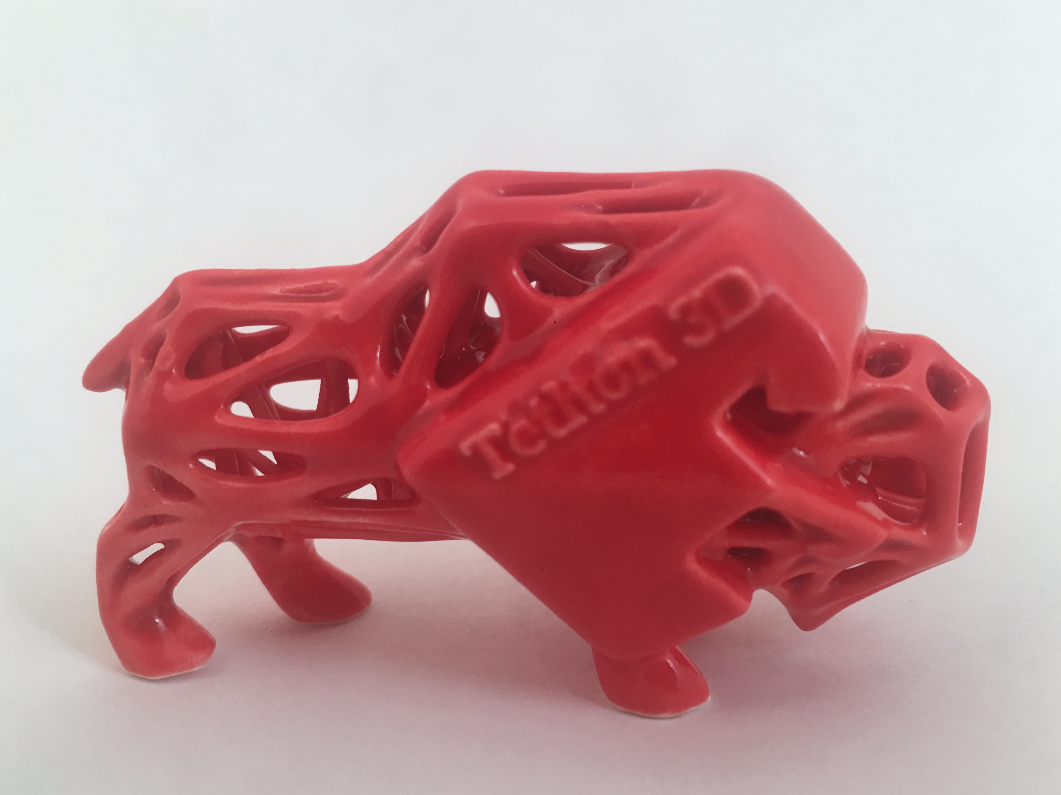
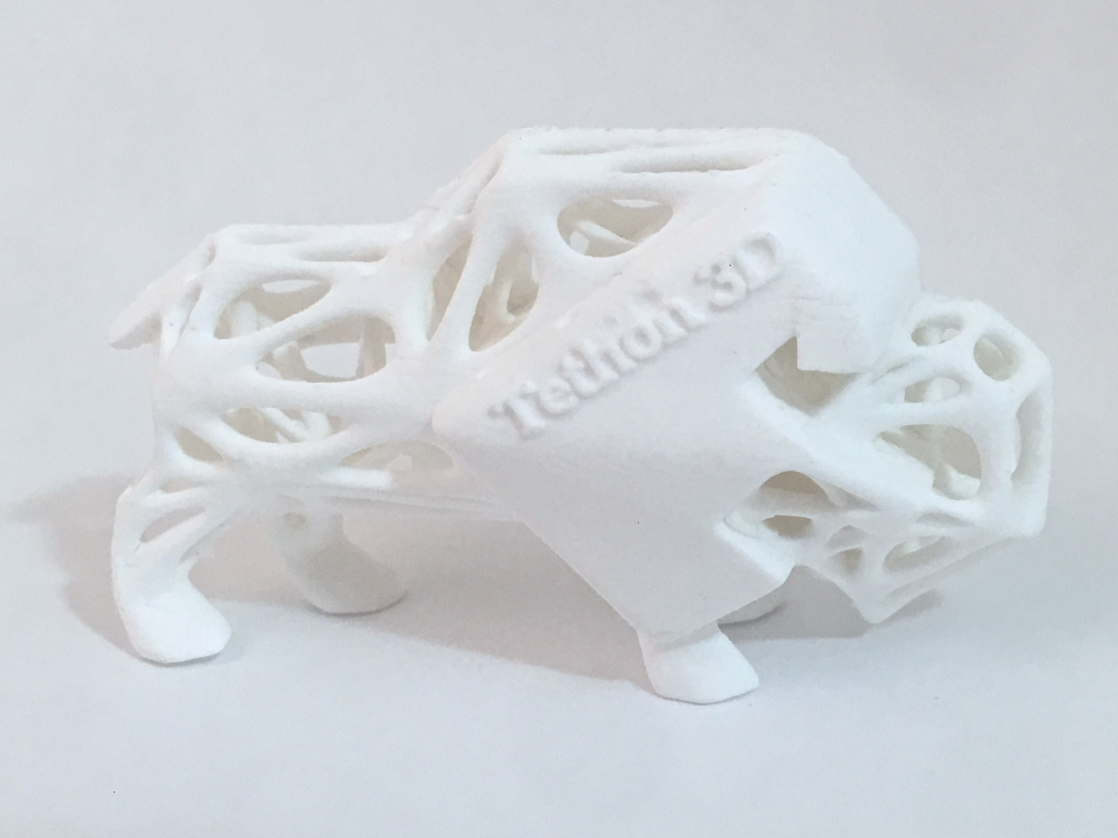
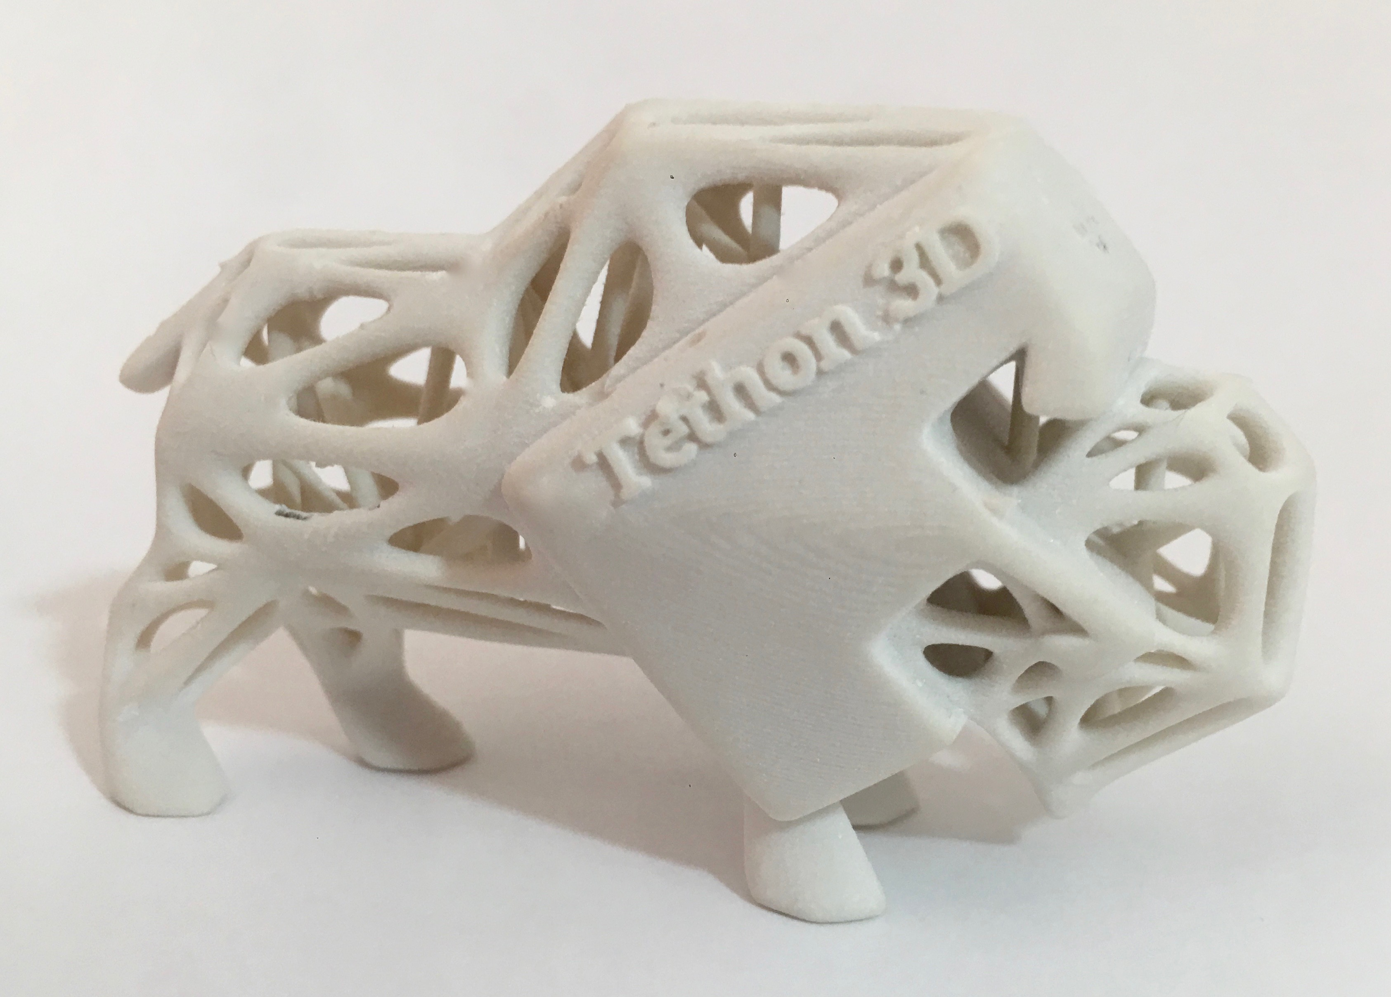
Applications for Porcelite include specialized manufacturing, fine art, engineering, architecture, design, and more.
Unfired Porcelite®
Once fired Porcelite®
Glazed Porcelite®
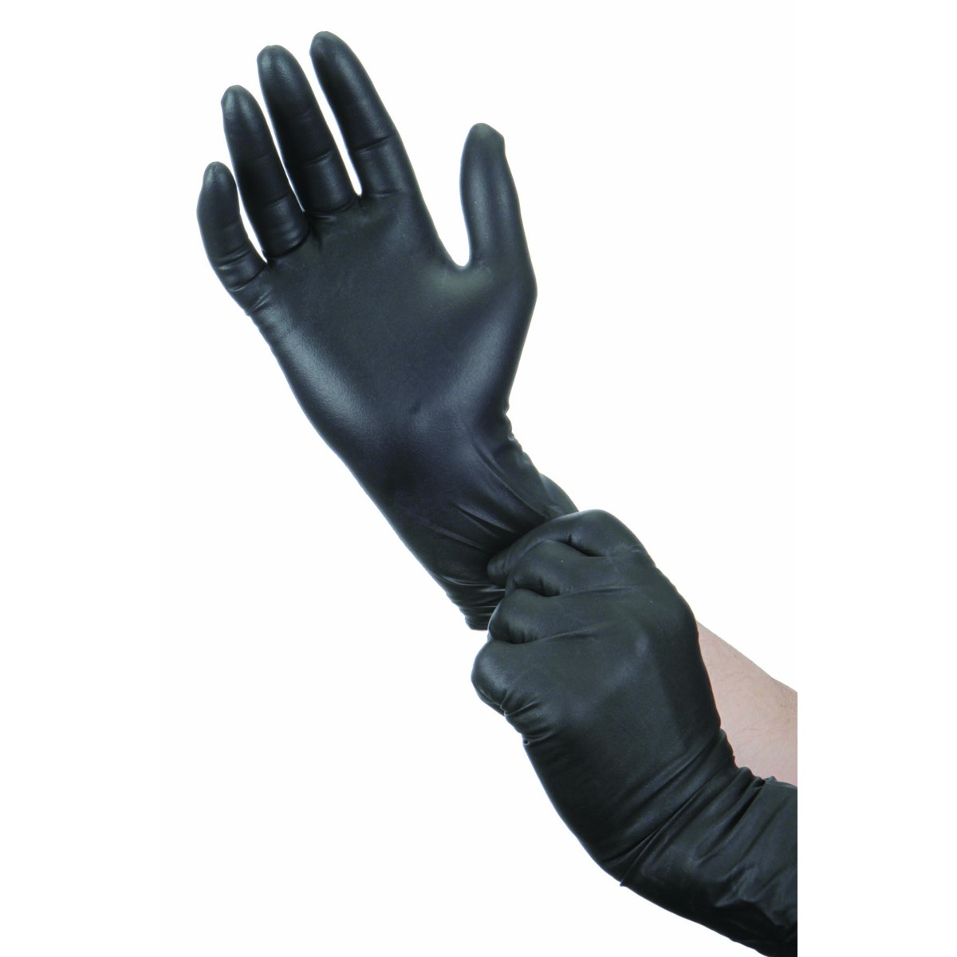
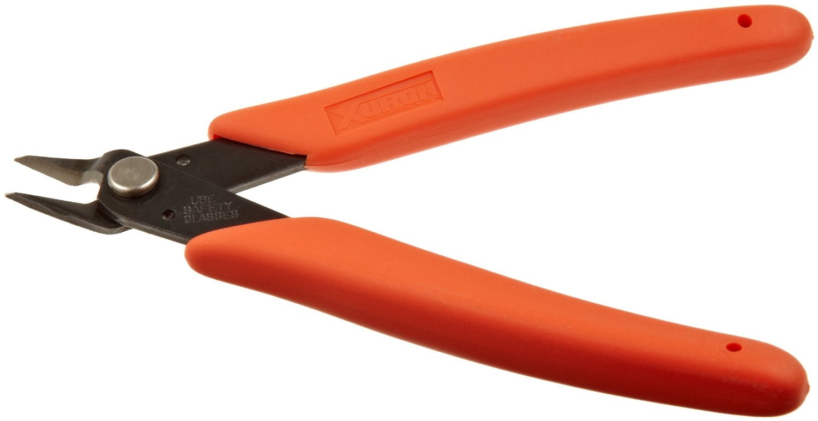
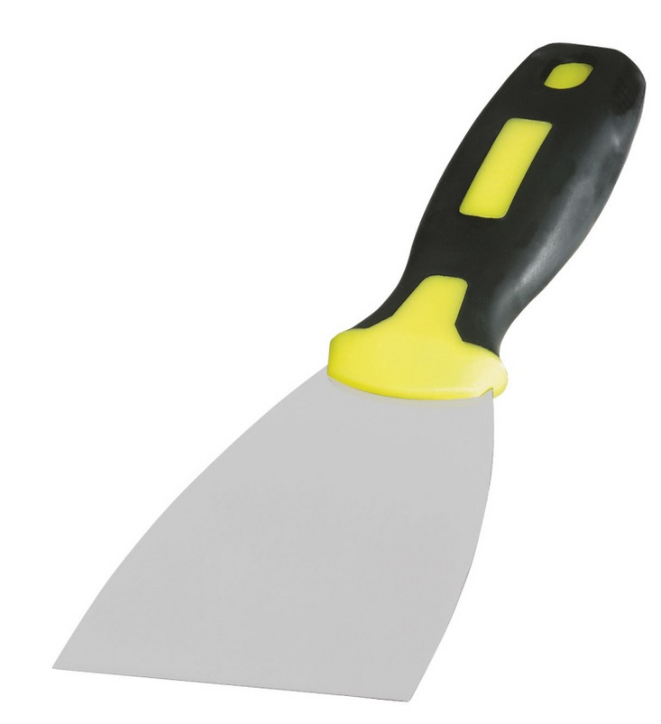
Recommended Printing Tools
Wear safety glasses when handling Porcelite
Wear nitrile gloves when handling Porcelite
Metal Paint Scraper to remove object from build bed
Plastic Paint Scraper to remove settled clay resin from bottom of resin tank after printing
Kitchen Stainer to filter Porcelite

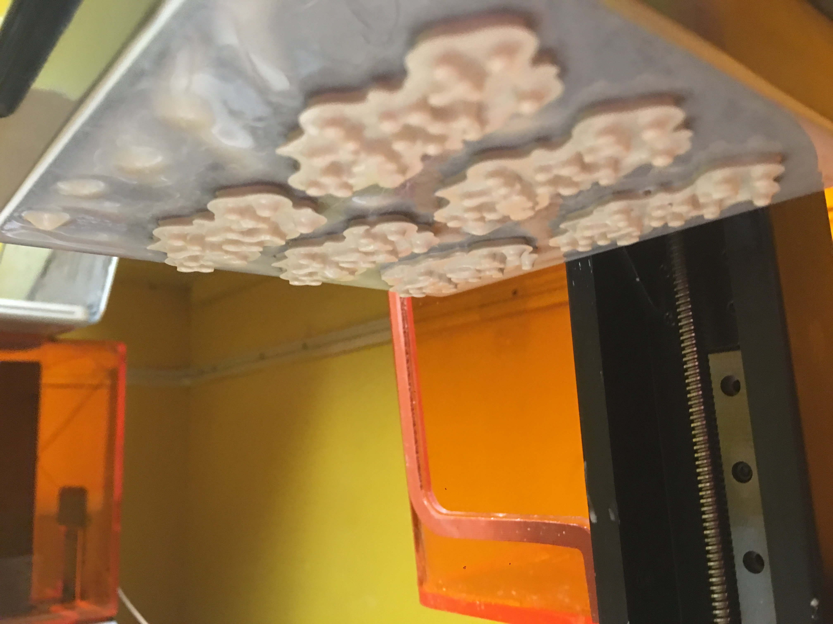
Wire Cutters to remove supports from 3D print
Printing Guidelines
1. Shake the Porcelite bottle upside down for 5 minutes. Ensure all of the ceramic material is mixed before printing.
2. Add Porcelite to resin tray as directed.
3. The first time printing in Porcelite it is recommend to make a small object to test your machine and assess if there is any trouble shooting required before printing at large scale.
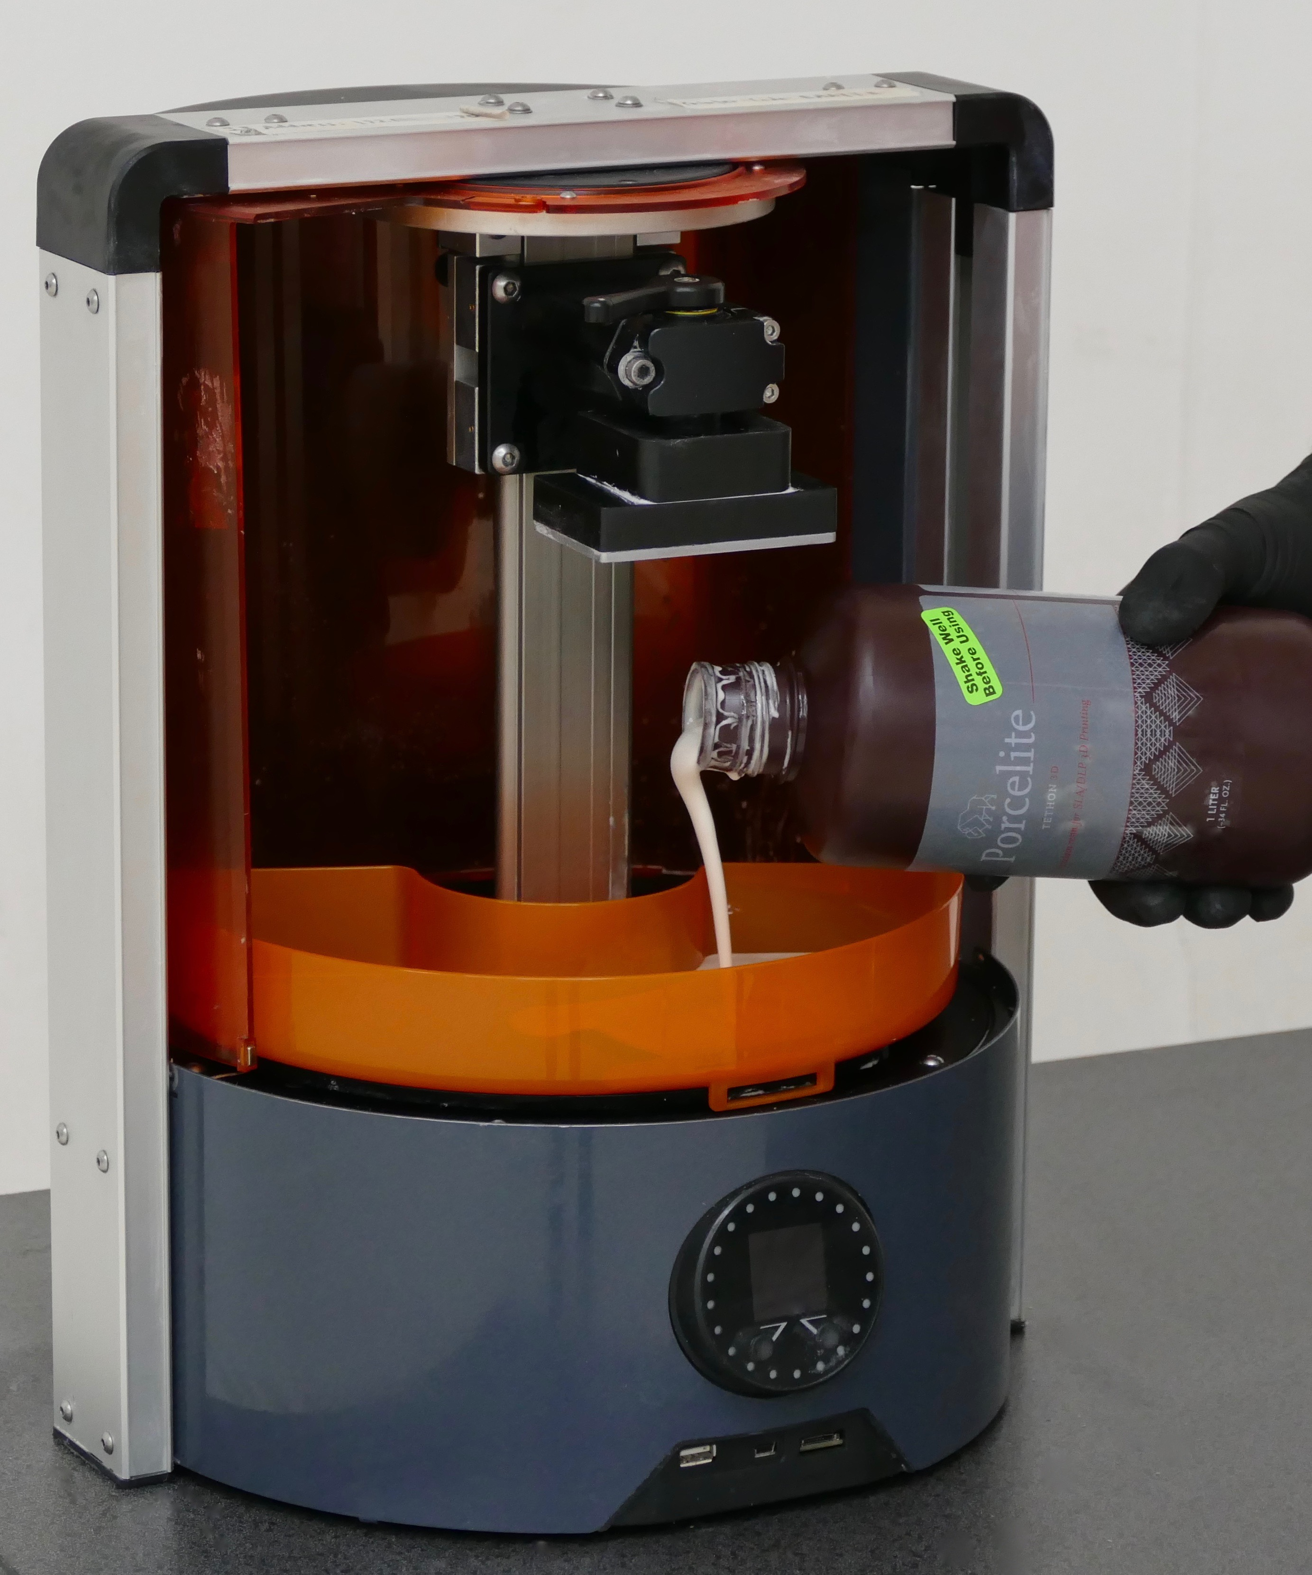
4. Remove wiper bar if available. Print five layers and pause printer to assess if design is adhering to the build plate. If it is, attach wiper bar and continue. If not, follow Troubleshooting steps.
Porcelite®
Pausing a printer to check for adherence
When recycling leftover Porcelite after a print, we recommend pouring the leftover Porcelite through a kitchen strainer to break up sediment. Mix leftover Porcelite back into the original bottle and shake well before printing again.

Printer Settings
- Porcelite works on most castable settings for SLA / DLP 3D printers.
- Increasing exposure will lead to best results. Settings with the longer exposure times will result in better parts.
Adding liquid Porcelite to printer
- Flexible settings can be used for delicate parts.
- Average first layer cure time is 15 seconds.
- Average burn layer is 10 seconds.
- Average general layer is 8 seconds.

Printing Tips
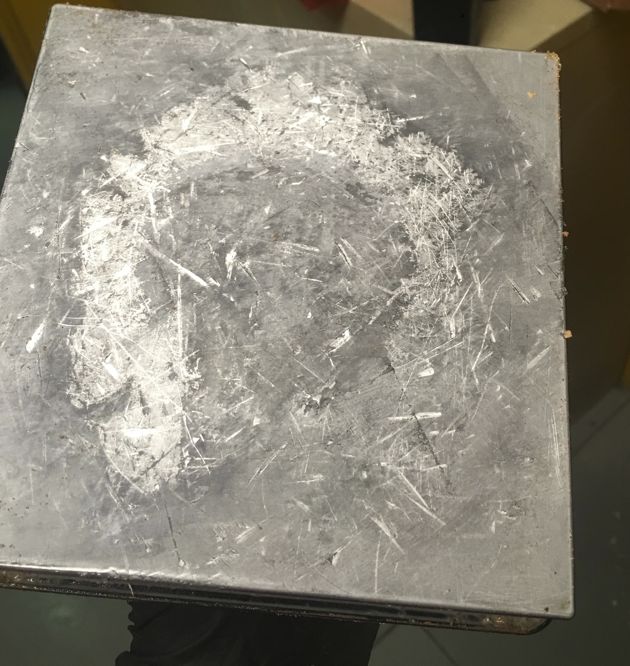
1. Porcelite is heavier than most 3D printing resins. It may require increased contact size on supports. Increasing the density of the supports will also ensure for a successful print.
2. Clean your build platform with Isopropyl Alcohol. This ensures there is no other resin on the build platform that could interfere with Porcelite sticking to the build platform.
3. Scratch the build plate. Porcelite is heavier than most 3D printing resins it may need a rough surface to adhere to the build platform.
4. Increase the overall exposure time of the machine if prints are not sticking to the build platform.
Scratched build plate

Print Finishing
1. Remove object from the build bed by cutting the supports. (Scrape the base and remaining supports off build plate later with the metal paint scraper.)
2. Soak object in Isopropyl alcohol for no longer than ten minutes. (Warping may occur if soaked longer).
3. Cure 1-8 hours in a UV light box . Rotate every hour. Longer curing required for thicker more solid objects. Curing time can be equal to print time.
4. Remove supports (optional – see firing instructions).
5. Sand and file support marks on print, if necessary. (Sanding is easier unfired than after firing.)
6.Use the Plastic Paint Scraper to scrap settled resin from bottom of the resin tank.
7. Filter unused Porcerlite and sediment through a kitchen strainer.
8. Take the filtered Porcelite and pour back into the original Porcelite bottle.
9. Shake Porcelite bottle to remix.
Porcelite®

Firing Instructions
Porcelite should be fired to Cone 6-7 up to cone 10 (2250-2300F) for body maturity, but can be fired to a minimum of Cone 3 (2130 F). Bisque firing (first firing after printing process) must take place in an oxidized environment. Do not use a reduction firing environment for Porcelite bisque firing. Porcelite shrinks during firing. Parts will shrink between 13% - 17%. This is dependent on the geometry of the part and layer thickness.

Porcelite needs to be fired slowly between 350-900*f or 176 - 483*c. This ensures all of the gas escapes from the object. Firing the print too fast will cause the object to bloat and crack in the kiln.

Porcelite needs to be fired in a well vented kiln. Avoid breathing fumes generated during firing. DO NOT prop open the kiln lid. That allows fumes to escape into the room and may cause combustion of your objects within the kiln. (And yes, you may use unvented kilns that sit outdoors.)

Porcelite 3D prints can be supported in the kiln to prevent warping. Unfired Porcelite objects may be fired with the printed support fixture and/or placed on a thin clay slab. The choice is dependent upon the design of the object (risk of warpage, base design, overall size). A natural clay slab or support structure helps objects shrink and prevents breakage and warpage. Porcelite prints may also be fired with printing supports still attached and broken off later. (See Firing tips for more information)

Kiln Firing Schedules for Porcelite 3D Prints

Slow Bisque for Large or Solid walled vessels, Cone 6 (1.5 mm - 5mm thick walls)
TOTAL TIME = approximately 24 hours
A slow ramp up to 1200F is required to prevent cracking.
0 – 600*f 50*f per hour Hold 1 hour can go as low as 25* per hour for thick parts over 5mm
600 – 1200*f 50*f per hour
1200 – 1900*f 200*f per hour
1900 – 2250*f 270*f per hour
Cool down naturally

Fast Bisque for open lattice type objects, Cone 6 (.5 mm - 1.5mm thick walls)
TOTAL FIRING TIME = approximately 12 hours
0-1200*f 150*f per hour
1200 – 1900*f 200*f per hour
Porcelite®
1900 – 2250*f 270*f per hour
Cool down naturally

Firing Tips

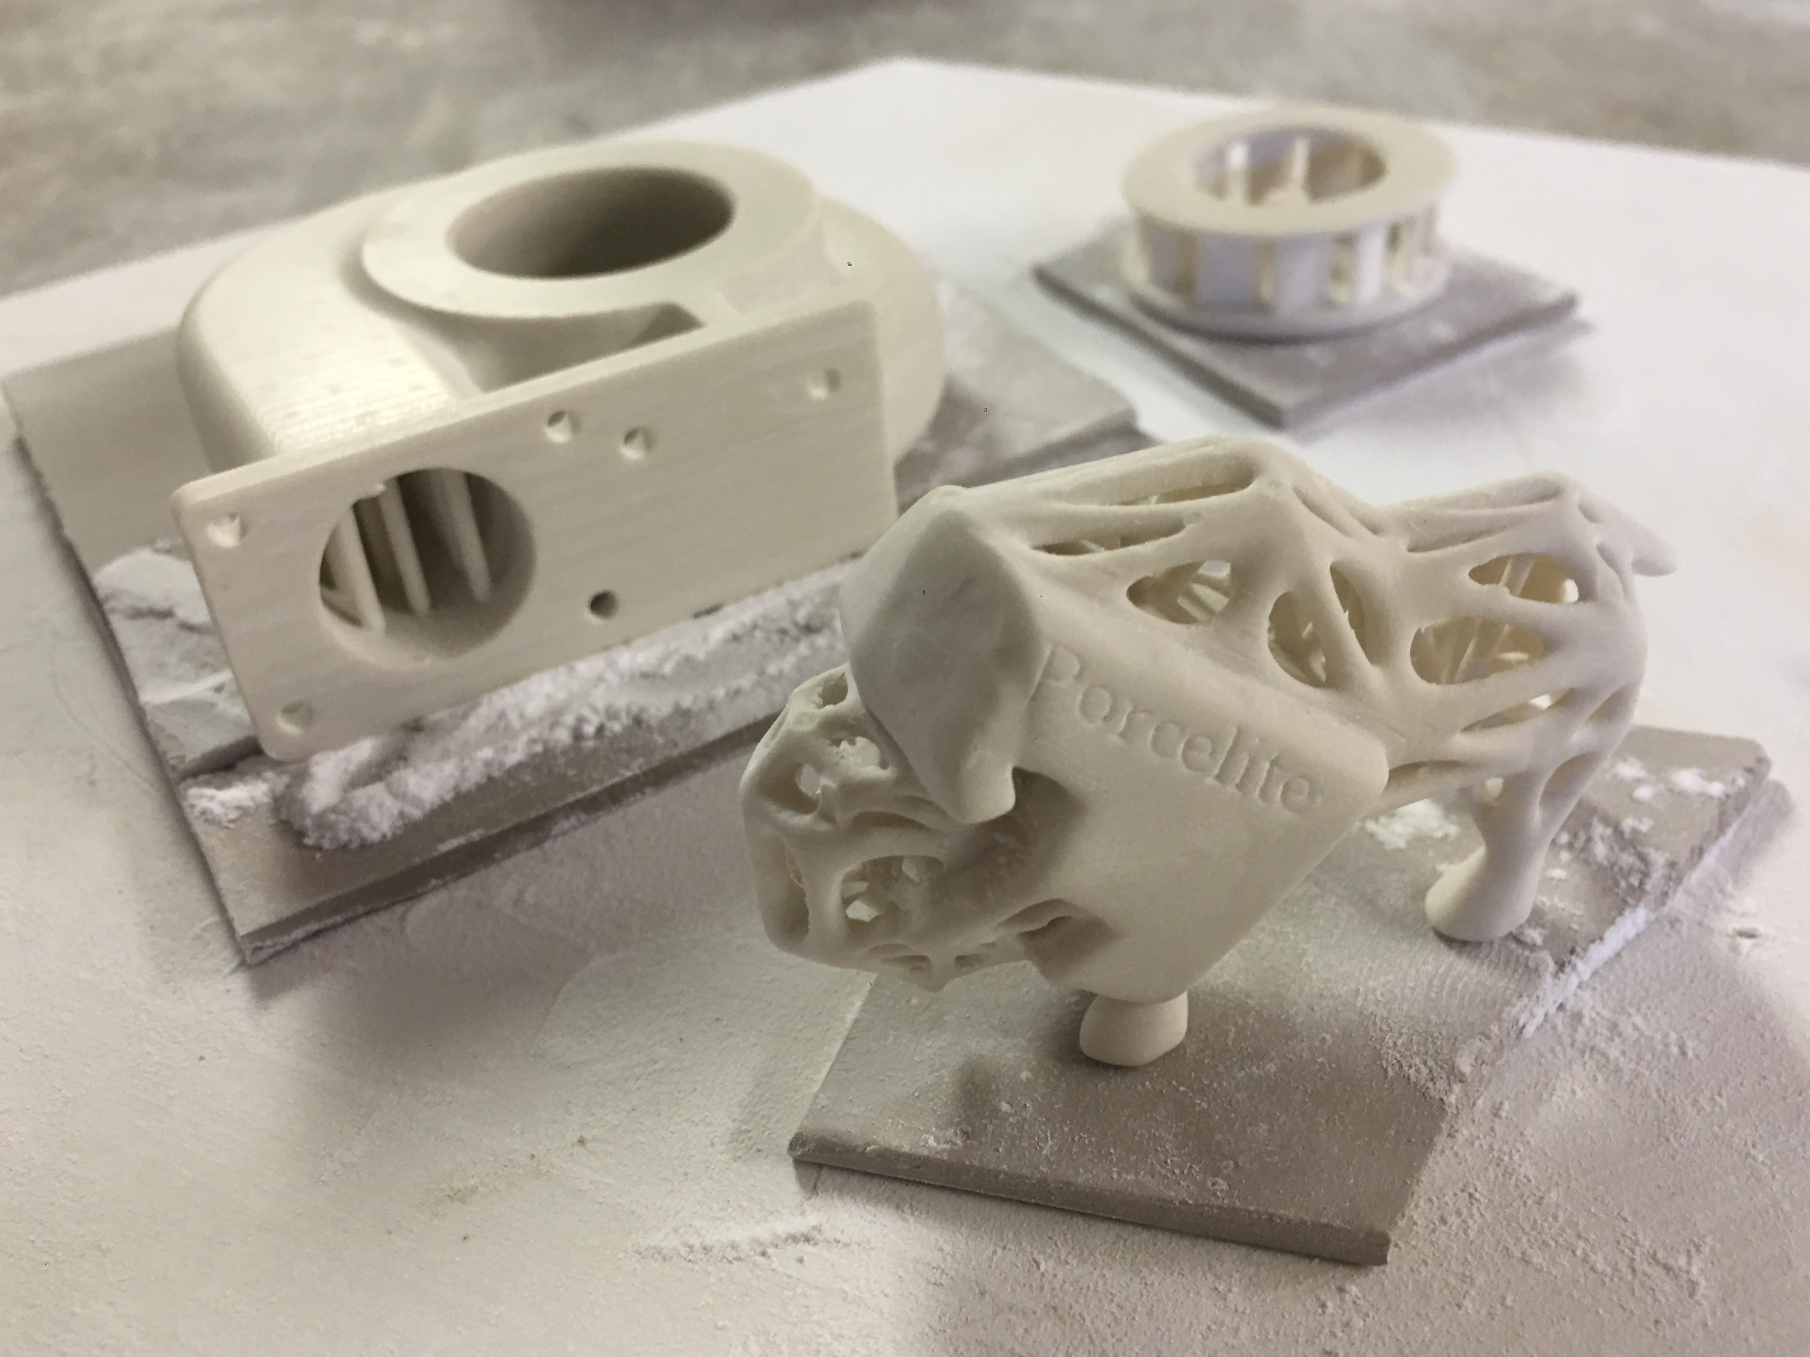
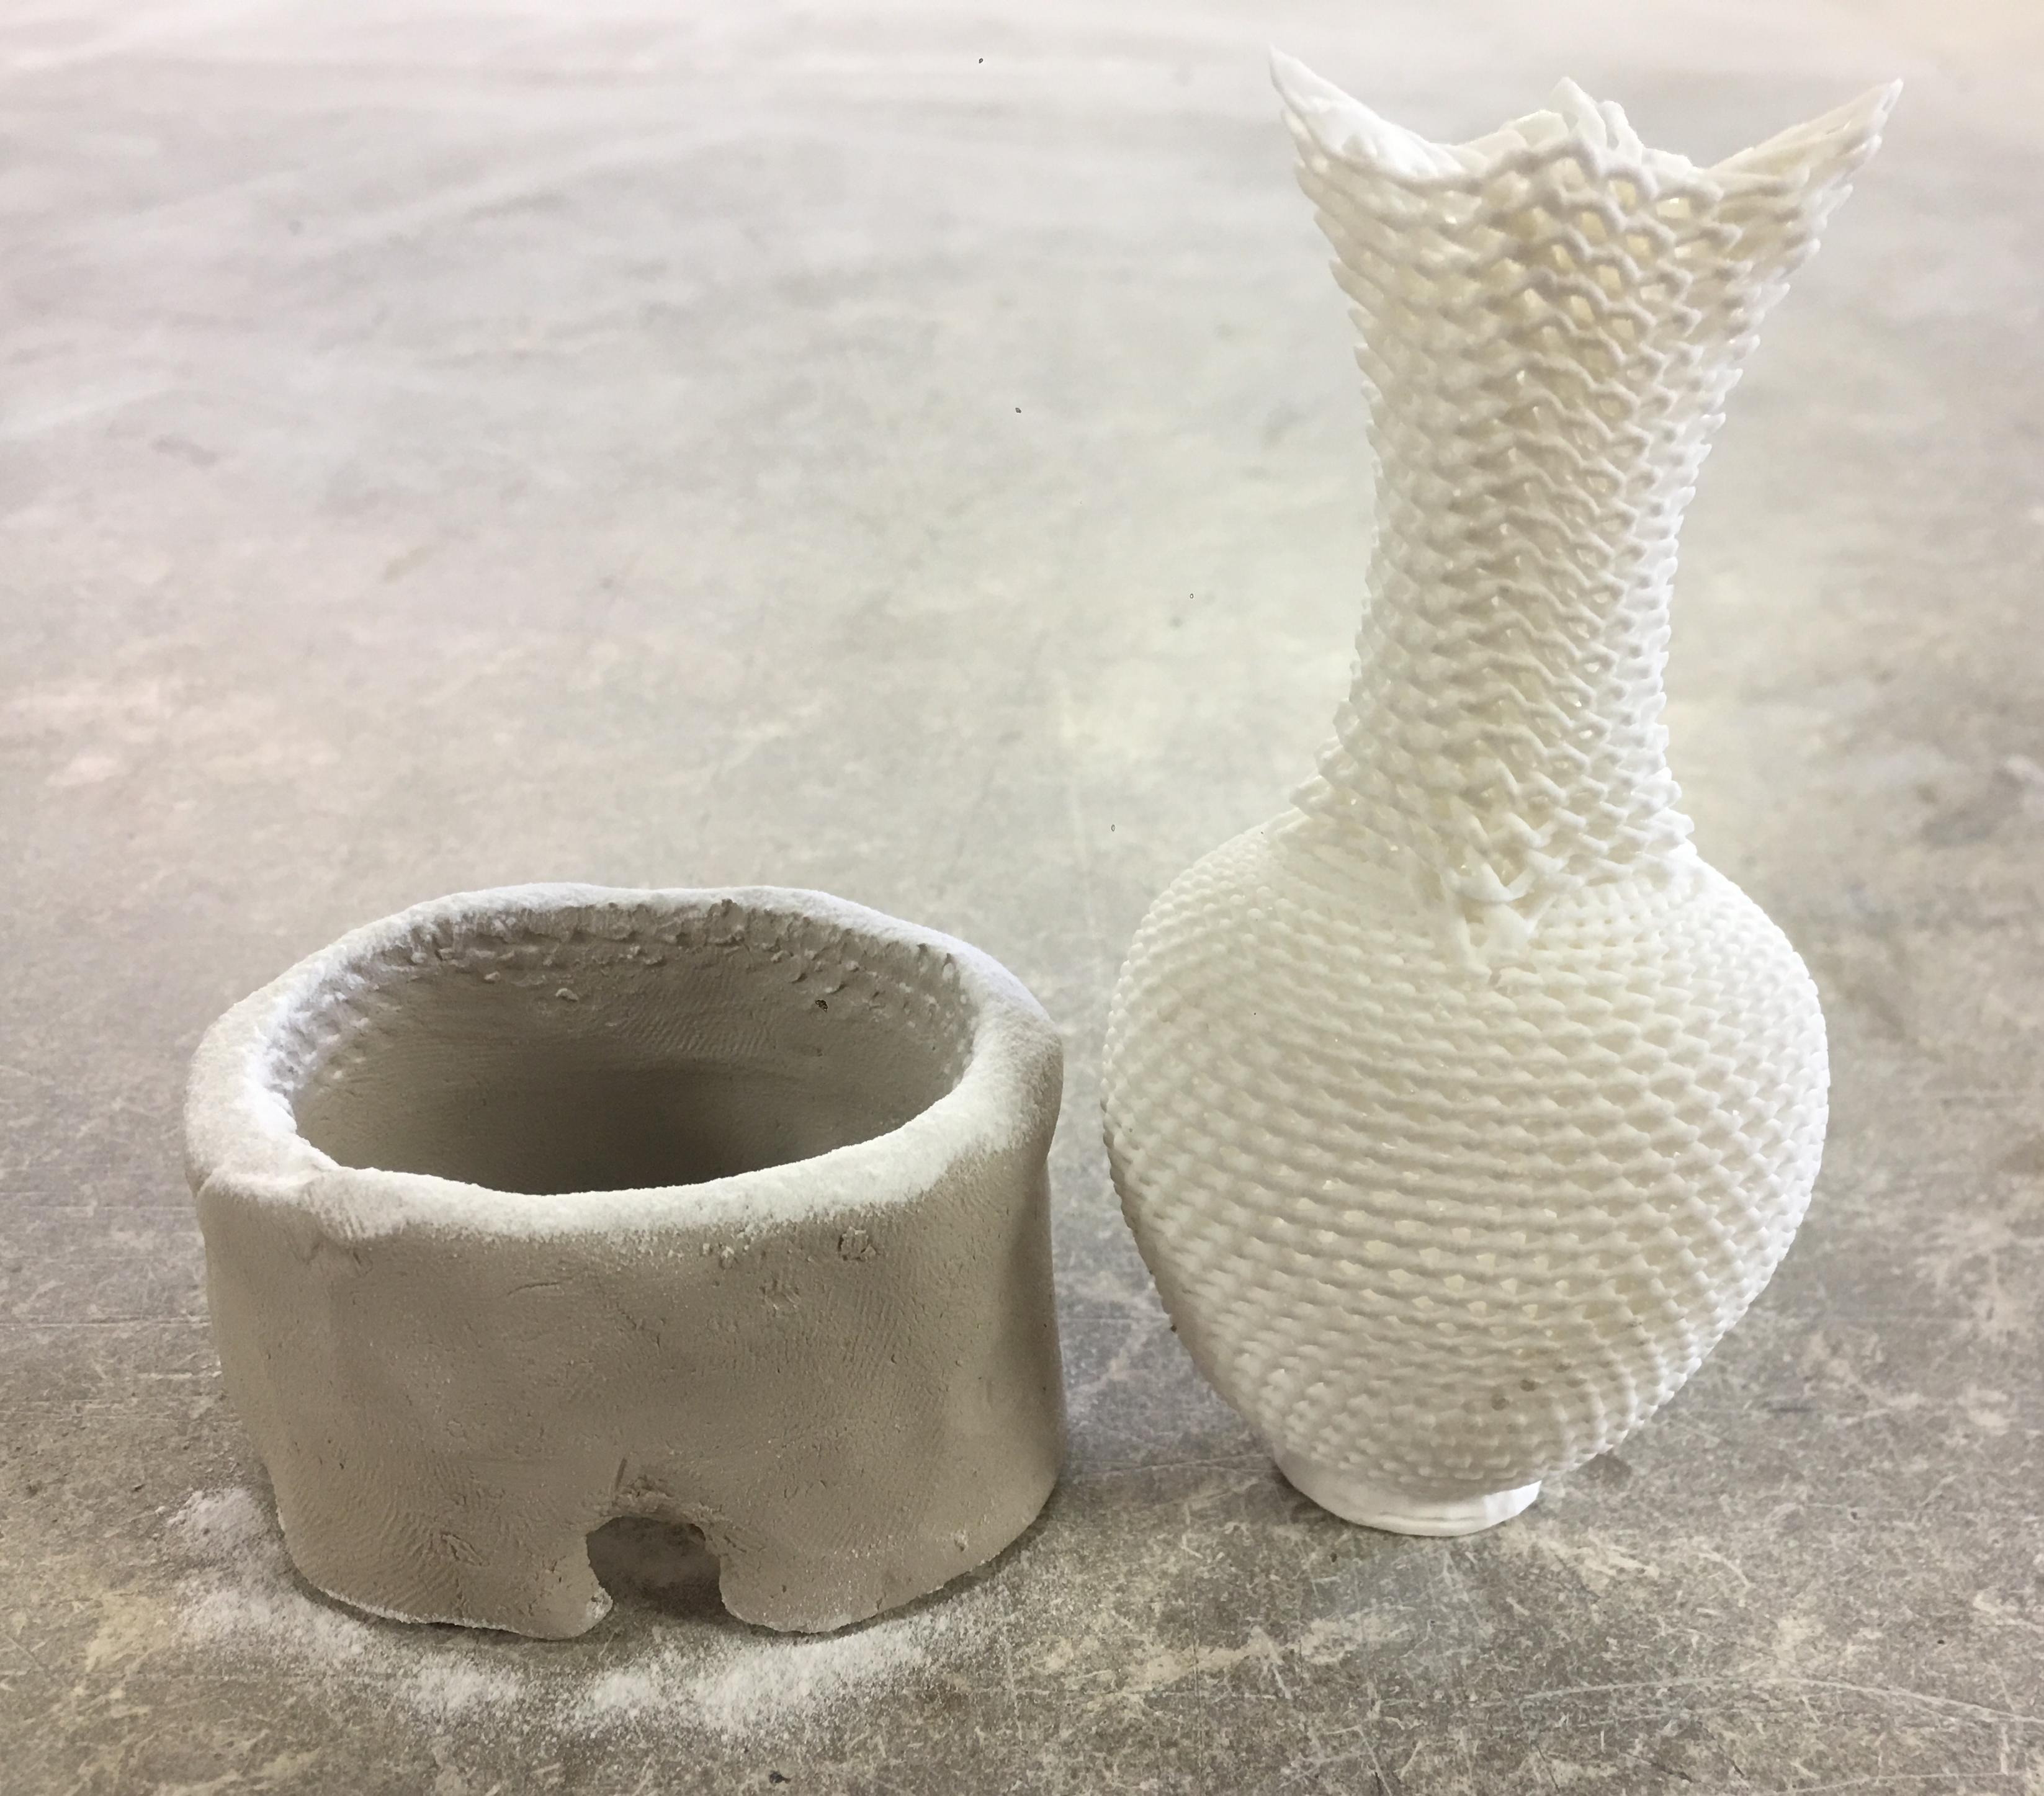
For objects with overhangs or design features at risk of warping, extra support may be required during kiln firing. Natural clay can provide support.
For objects with overhangs or design features at risk of warping, extra support may be required during kiln firing. Natural clay provides support when firing tall objects. If an object is wider at the top than at the base, use natural clay to support it.
For objects that are wider than they are tall it is best to fire on a natural clay slab to help prints shrink in the right direction. The clay slab will pull against the print helping it shrink. Place the dry slab on a kiln shelf and sprinkle the surface with aluminum hydrate place the Porcelite object on the slab in the kiln.
Porcelite®
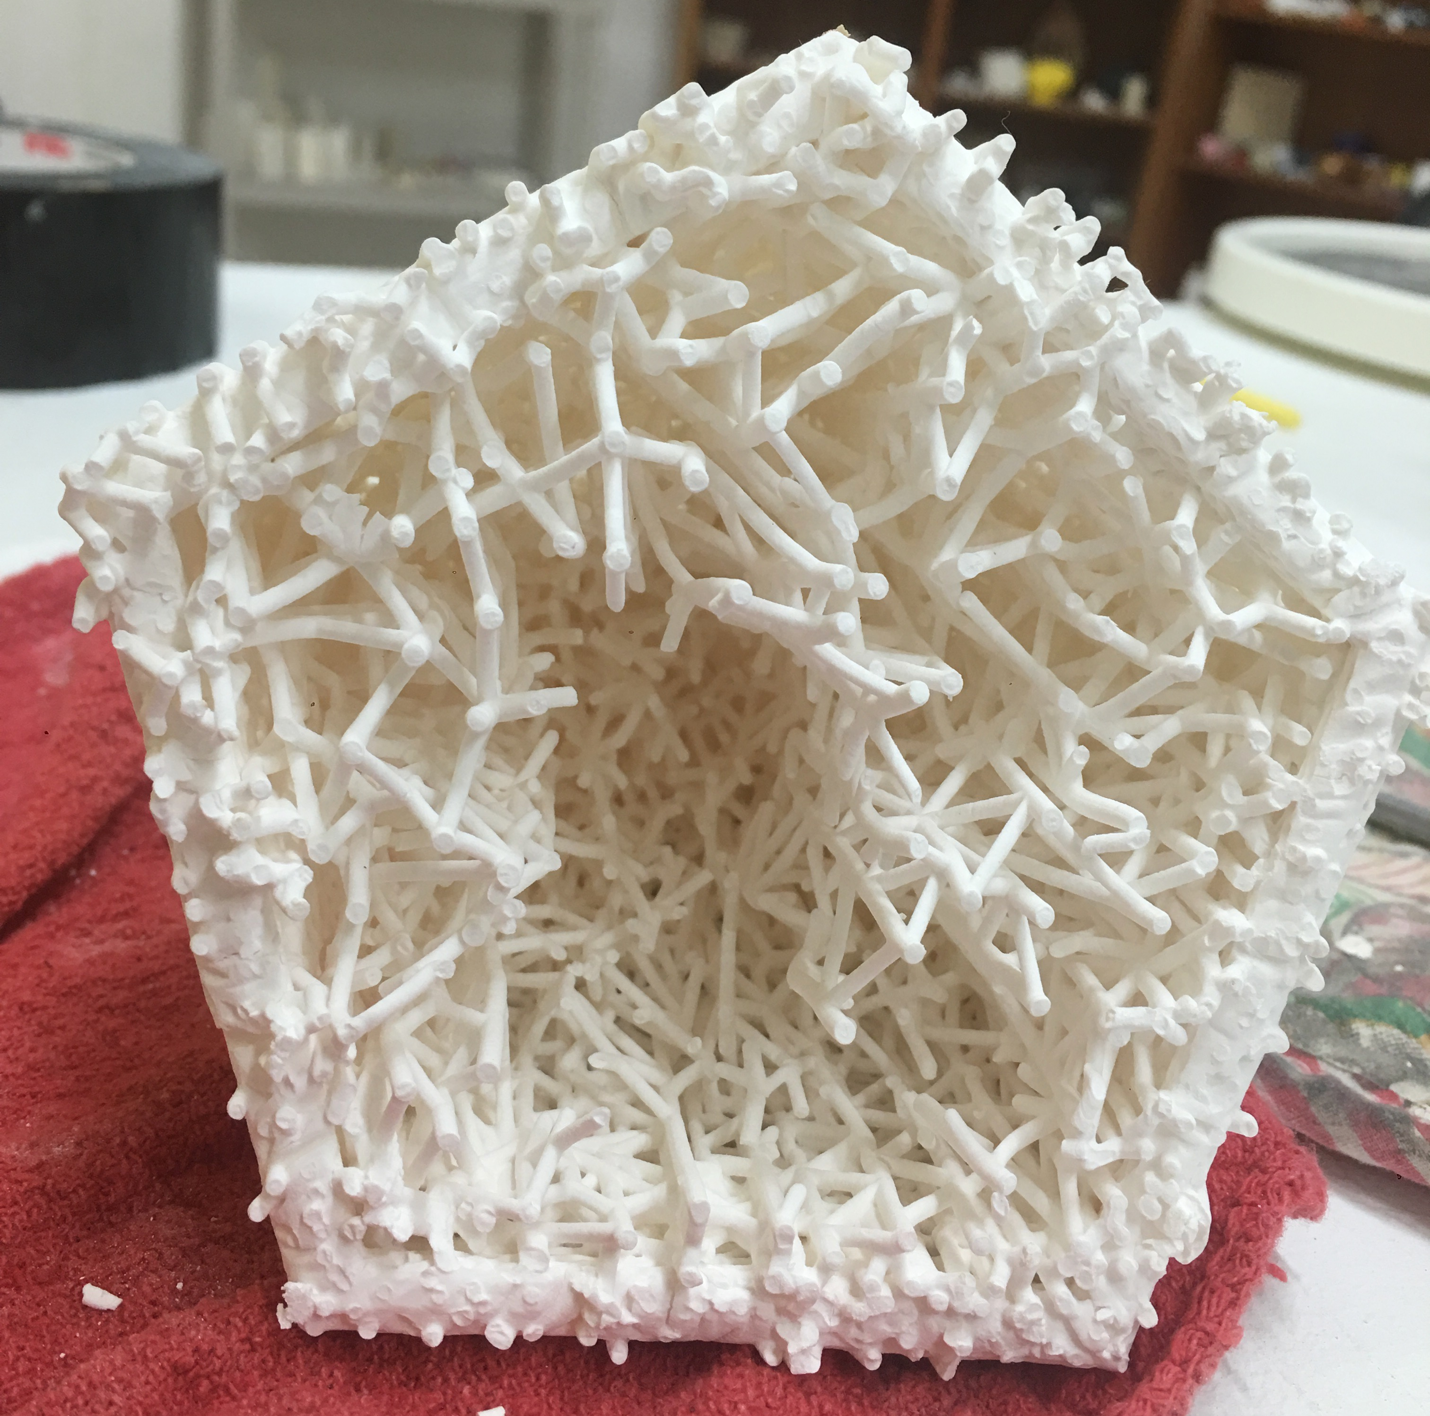
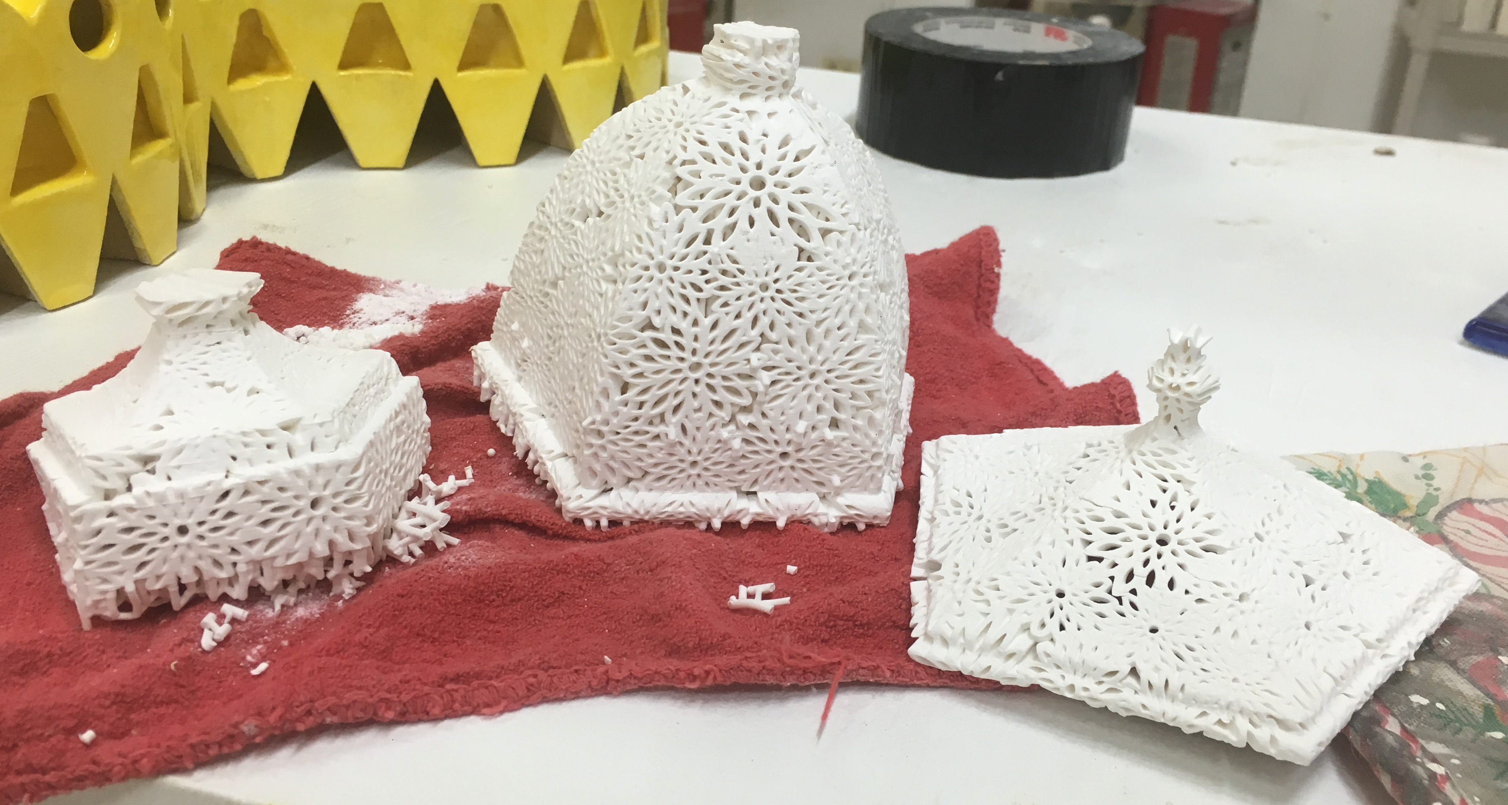
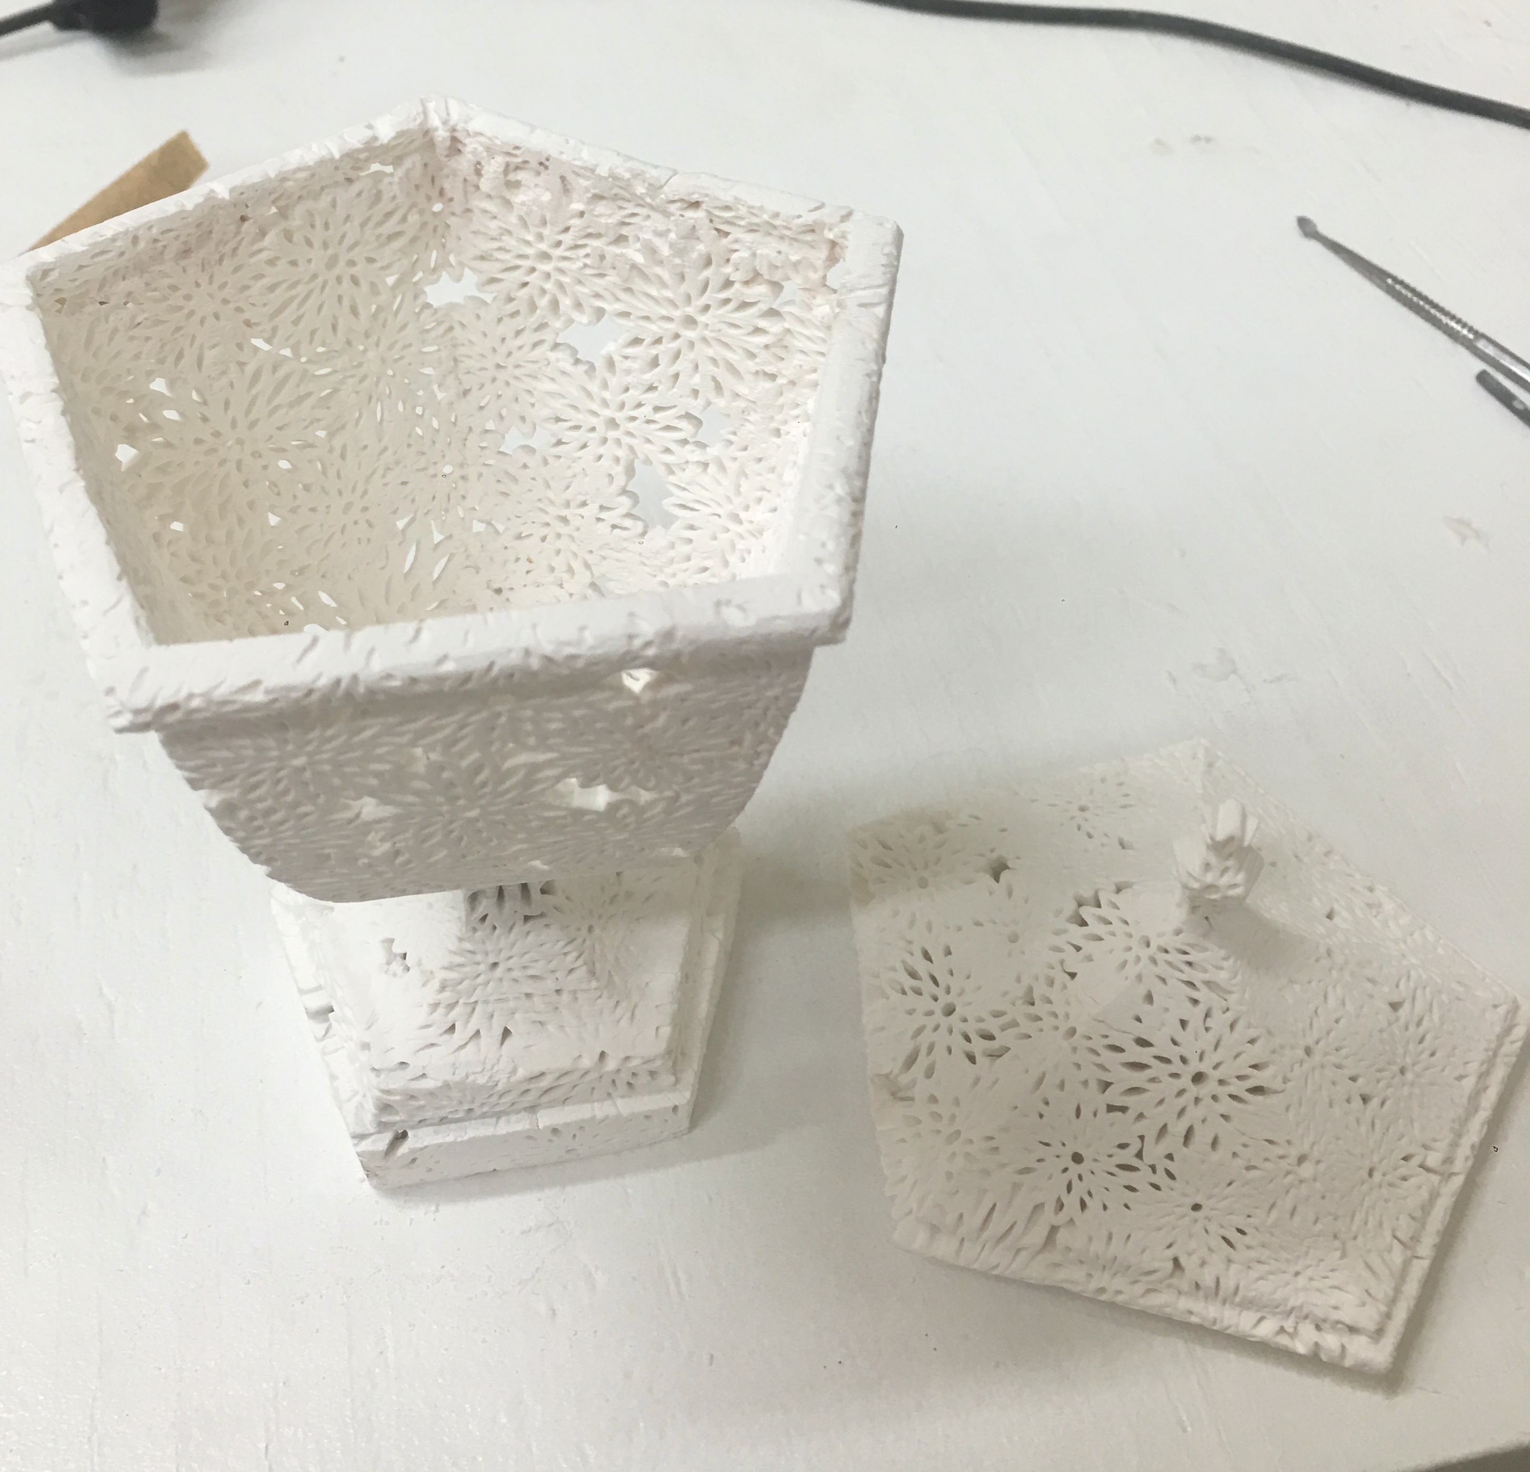
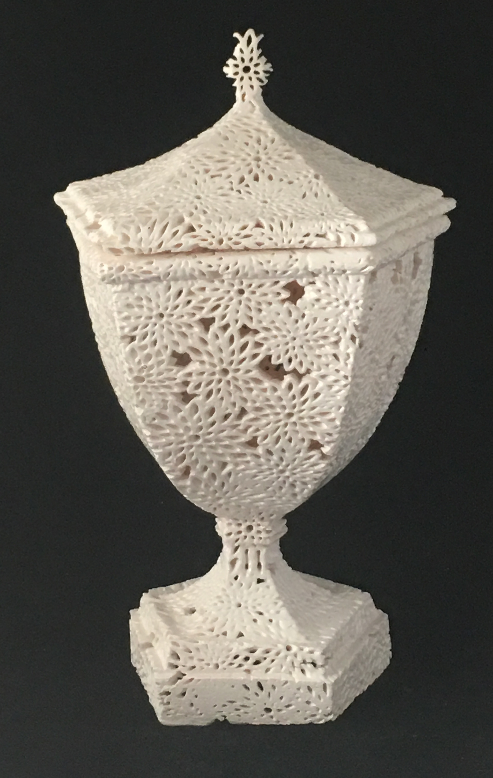
Arita by Michael Eden 2016. Represented by Adrian Sassoon, London
Objects can also be made in parts and assembled together later using a ceramic bisque glue
Objects can be fired on their printer fixtures. The supports can be removed and sanded down after firing. The printer supports act as firing supports.
Porcelite®
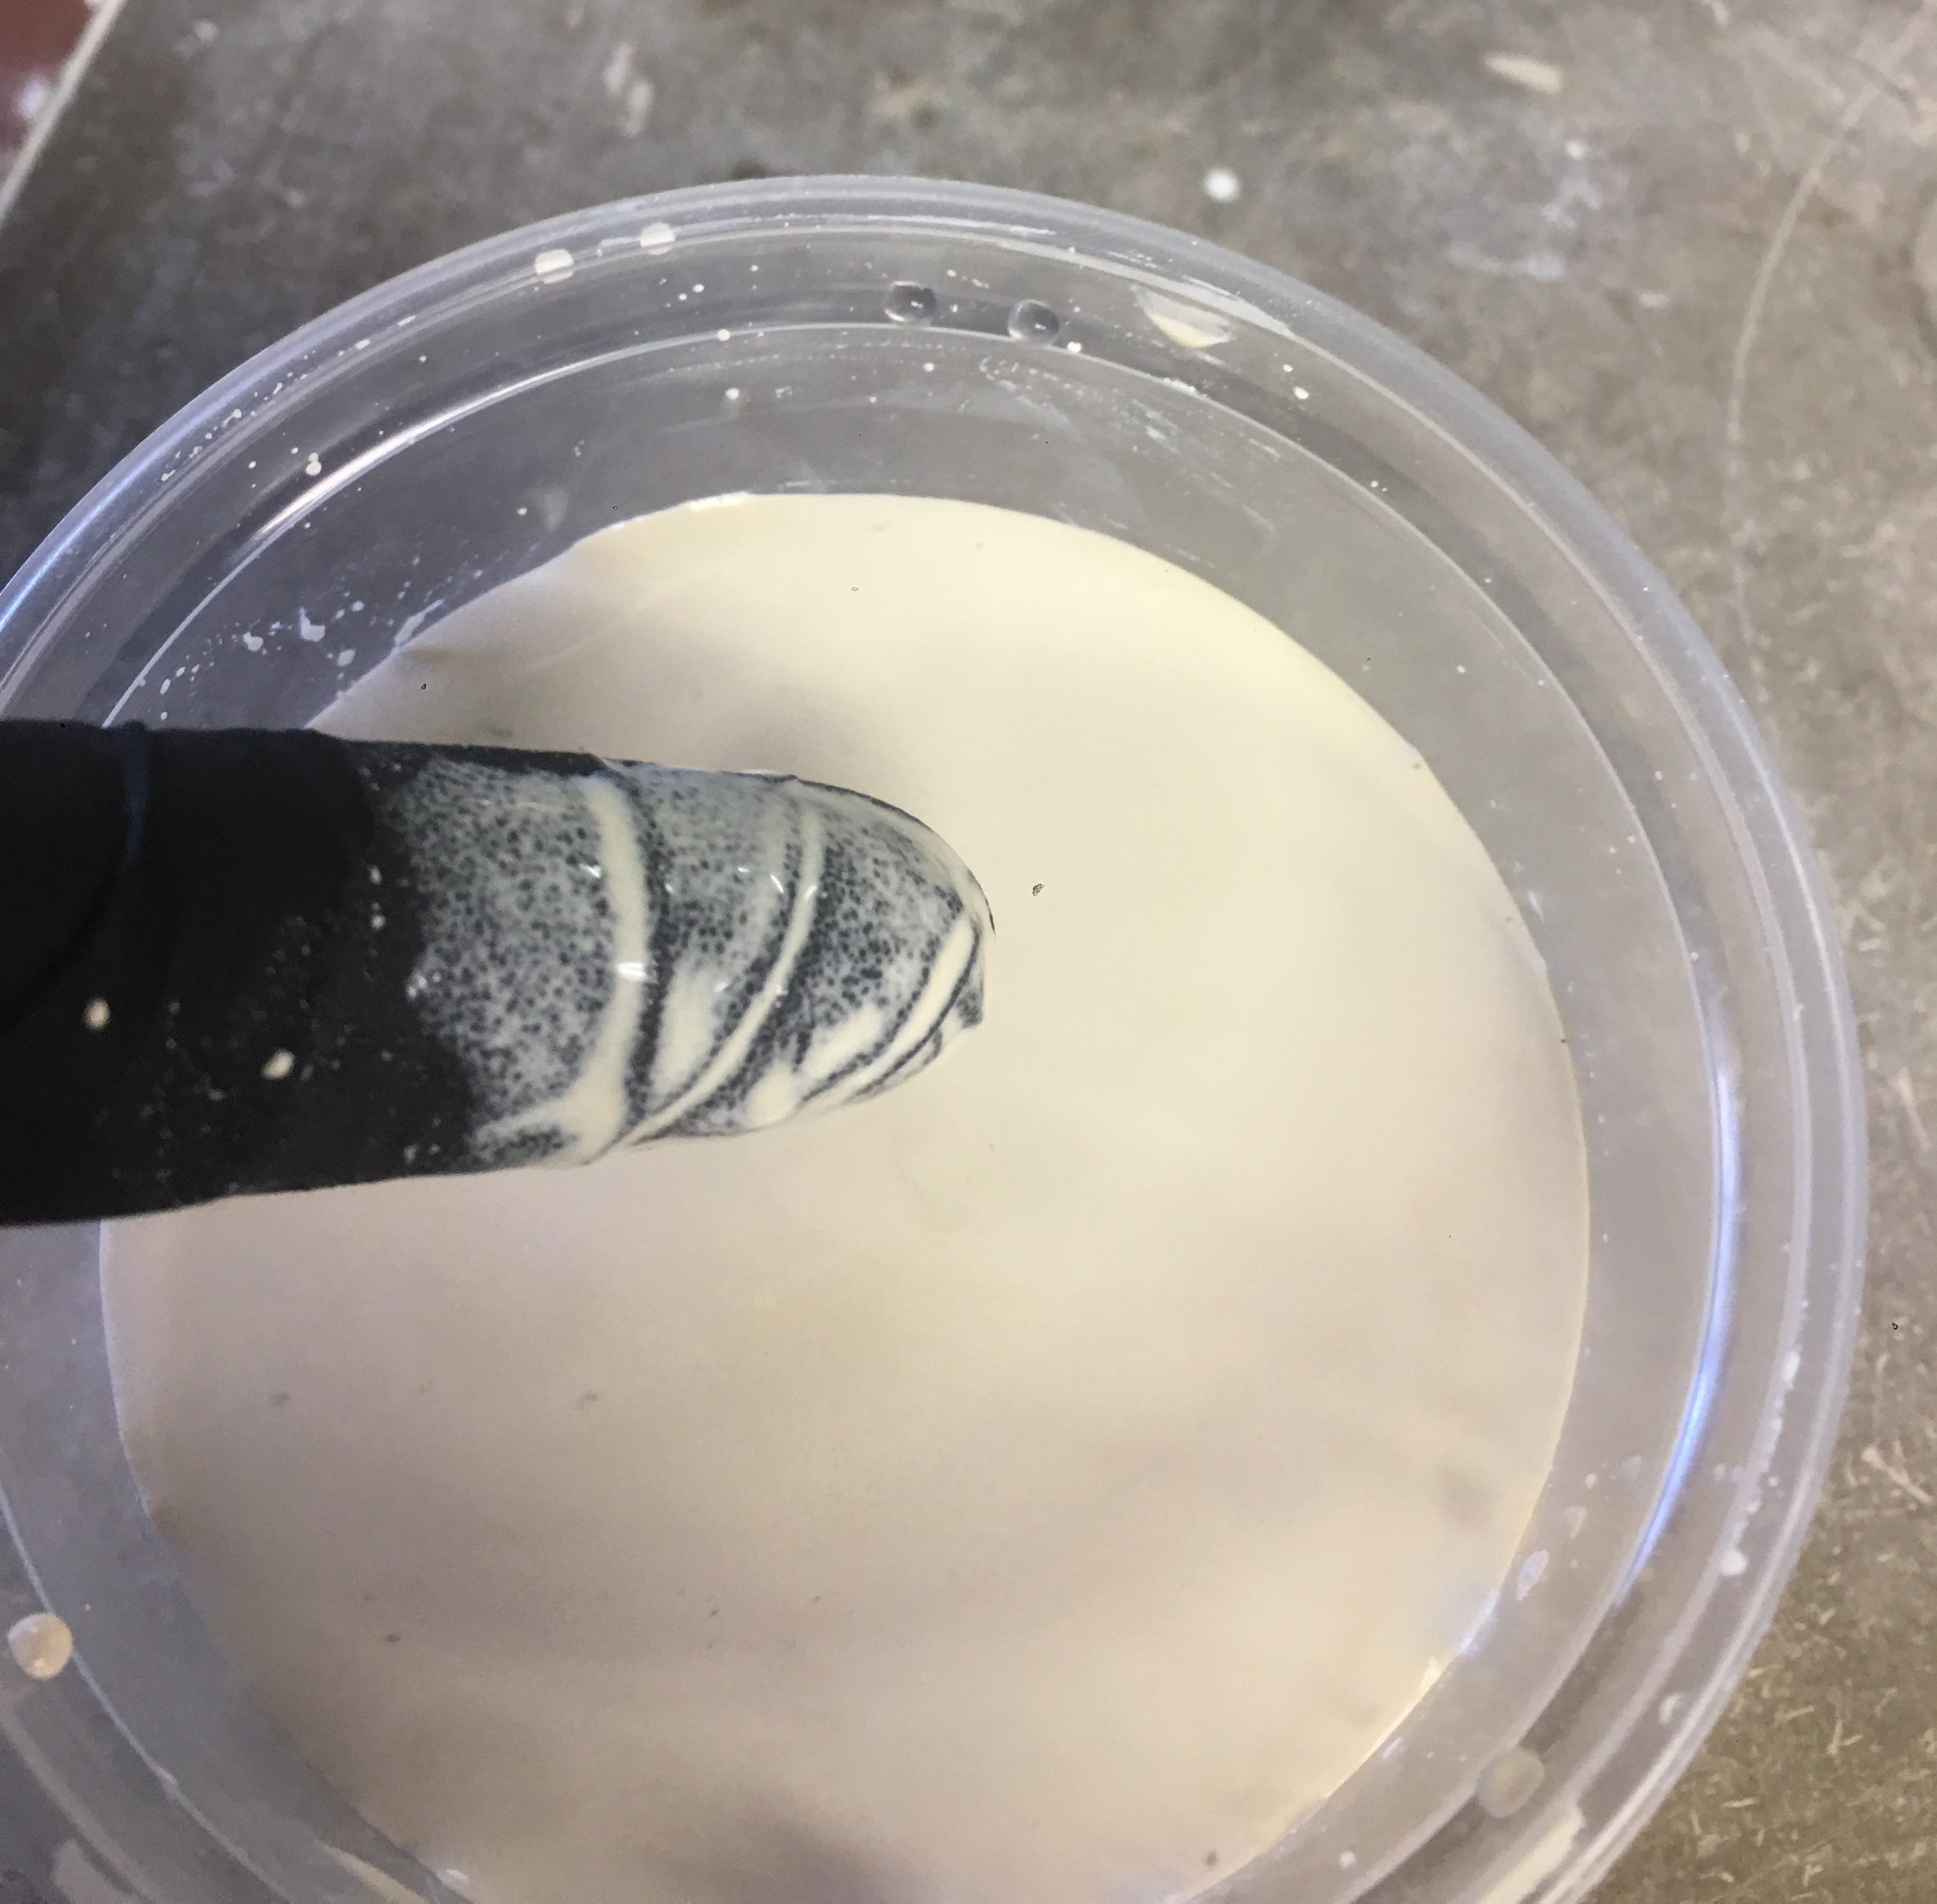
Artistic Finishing Technique
Technical Ceramic Finishing
The fired Porcelite object can have a variety of glazing treatments applied to reach the desired final goal. Glazes and Slips can be applied directly to the surface of the Porcelite. These materials can help you produce a range of surface finishes, and can decrease surface porosity. Glazing increases the final strength of the part as well. Follow the firing instruction of the glaze manufacturer. Porcelite does not need to be fired slow once it has been bisque fired.
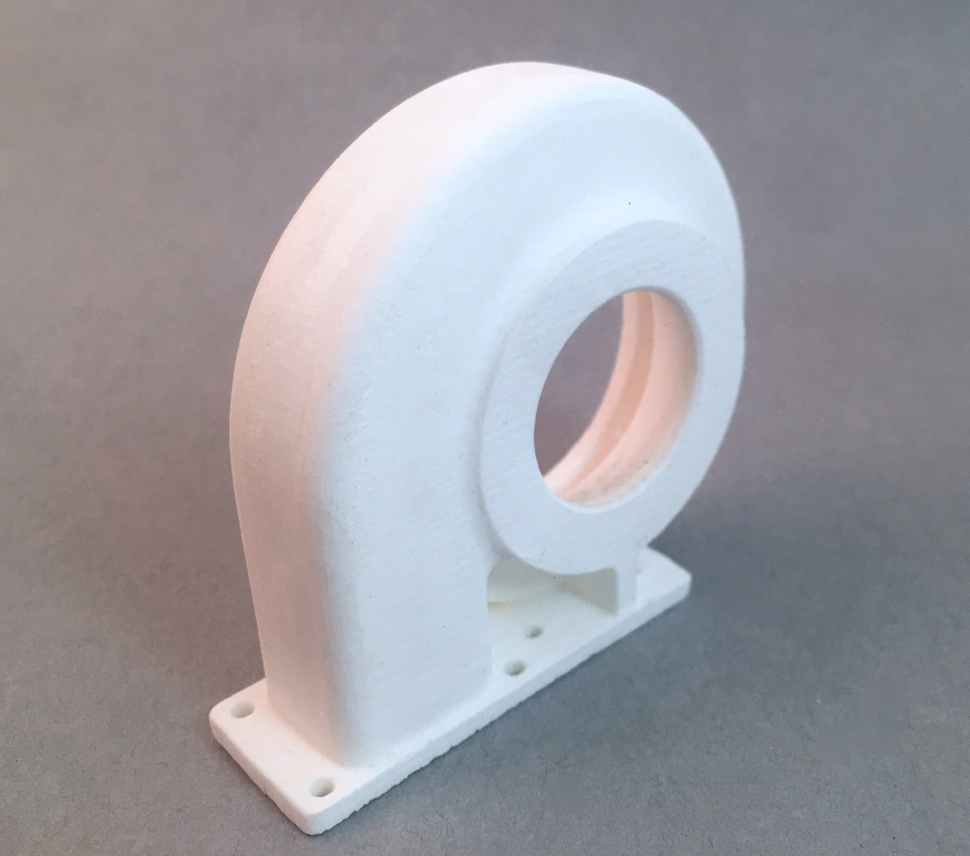
Porcelite®
Sanding Porcelite after first firing is possible with diamond bit sand paper. This is great way to help remove supports after firing.
Many different glazes and slips work on Porcelite. They can be used individually or together to achieve the desired end result. For best preservation of detail while glazing it is best to use very thin coats of glaze or slip.
Repairing
Various tools can be used to finish Porcelite. Files and diamond sand paper can help remove support structures, Repairs can also be made to Porcelite using ceramic bisque glues. This can fill in imperfections or cracks in Porcelite after it has been once fired. Follow manufacturers instructions when using bisque glues, glazes and slips.
For parts that require low porosity and a polished finish, a thin coat of matte glaze can be applied to the surface. This will not effect overall part size. It will reduce surface porosity, making a smooth finished part. This also increases overall strength of the part.
Finishing and Glazing Tips
Design Tips
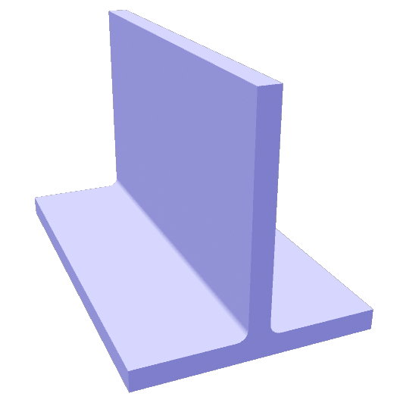
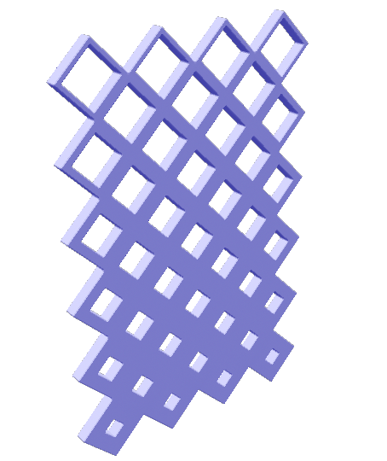
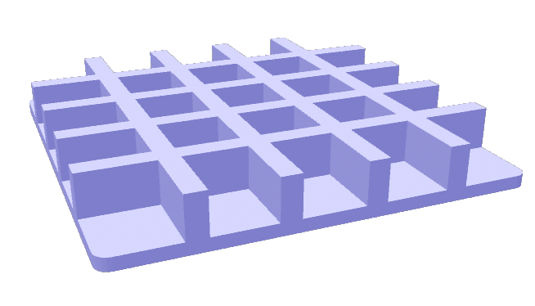
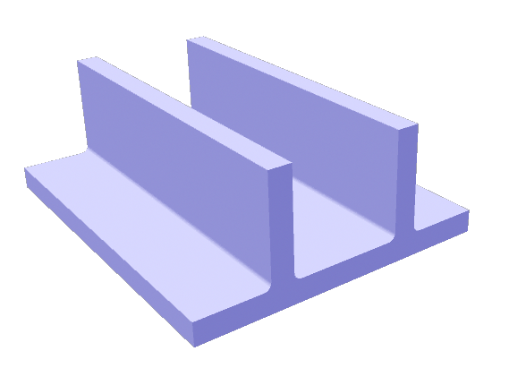
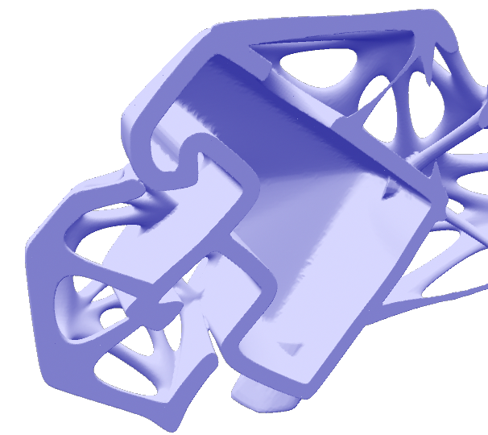
The following tips help achieve uniform shrinking during the kiln firing.
Porcelite®
Wall thickness
Structures need to be supported with appropriate wall thickness. Thinner walls will warp. Details can be less than your supporting wall. Thinner walls will reduce cracking
Using Ribs for interior solid wall supports
Using ribs on the interior of a thin solid wall will help reduce sagging during firing. A thin outer wall, with ribs supporting will improve firing results.
Rounding Corners
Rounding corner and where edges they meet can help reduce cracking during firing.
Lattice Thickness
Lattices will benefit from a structure that is thicker on the bottom than at the top. Lattice structures can be used for infill.
Hollow Models
Solid objects should be hollowed. 1mm - 3mm wall thickness is recommend, for desktop 3D printing. Do not trap unfired resin when hollowing models. Escape holes need to be added so the resin can escape. Trapped resin will cause cracking
Troubleshooting
Porcelite® works on most UV curing 3D printers. Sometimes there needs to be fine tuning to ensure the best quality porcelain objects from your 3D printer. Here are some tips if you are having trouble. Please contact Tethon 3D if problems persist.

Porcelite® not sticking to the build plate
First make sure the build plate is clean. Clean with isopropyl alcohol and paper towel.
Increase exposure setting on the 3D printer. Black or Castable settings often have the longest exposure times.
Lower the build plate further into the resin tank.
Decrease the layer thickness of the 3D model.
Scratch build plate.

Porcelite® has wings or ragging during printing
Filter and remix Porcelite® resin.
Reduce exposure settings.

Porcelite® is cracking during firing
Reduce firing speed between 300-900*f.
Decrease wall thickness, use ribs to increase strength and stability.
Increase exposure time for printing. Using castable settings will cure Porcelite longer in between layers. This will help reduce cracking as well.

Porcelite® warps during firing
See design guides to improve geometry of object.
Use thinner print layers.

Porcelite® settles during printing
Using a printer with a wiper bar will reduce or eliminate this.
This does not affect how Porcelite cures.
Use a plastic paint scraper to remove settled Porcelite and remix in original bottle.

Porcelite® gives off a strong odor during firing
Vent kiln during firing.

Porcelite® shrinks more than 17% after firing
Firing above cone 6 or 2250*F will shrink Porcelite® over 17%.
Make sure all of the Porcelite® is properly mixed. If all the resin is not mixed together at the time of printing greater shrinkage may occur.

Storage of Porcelite®
Store in a dark cool room free from moisture.
Shake Porcelite® bottle for a few minutes every two weeks.
Remove Porcelite® from resin tray if not in use for over 3 days.

Porcelite®

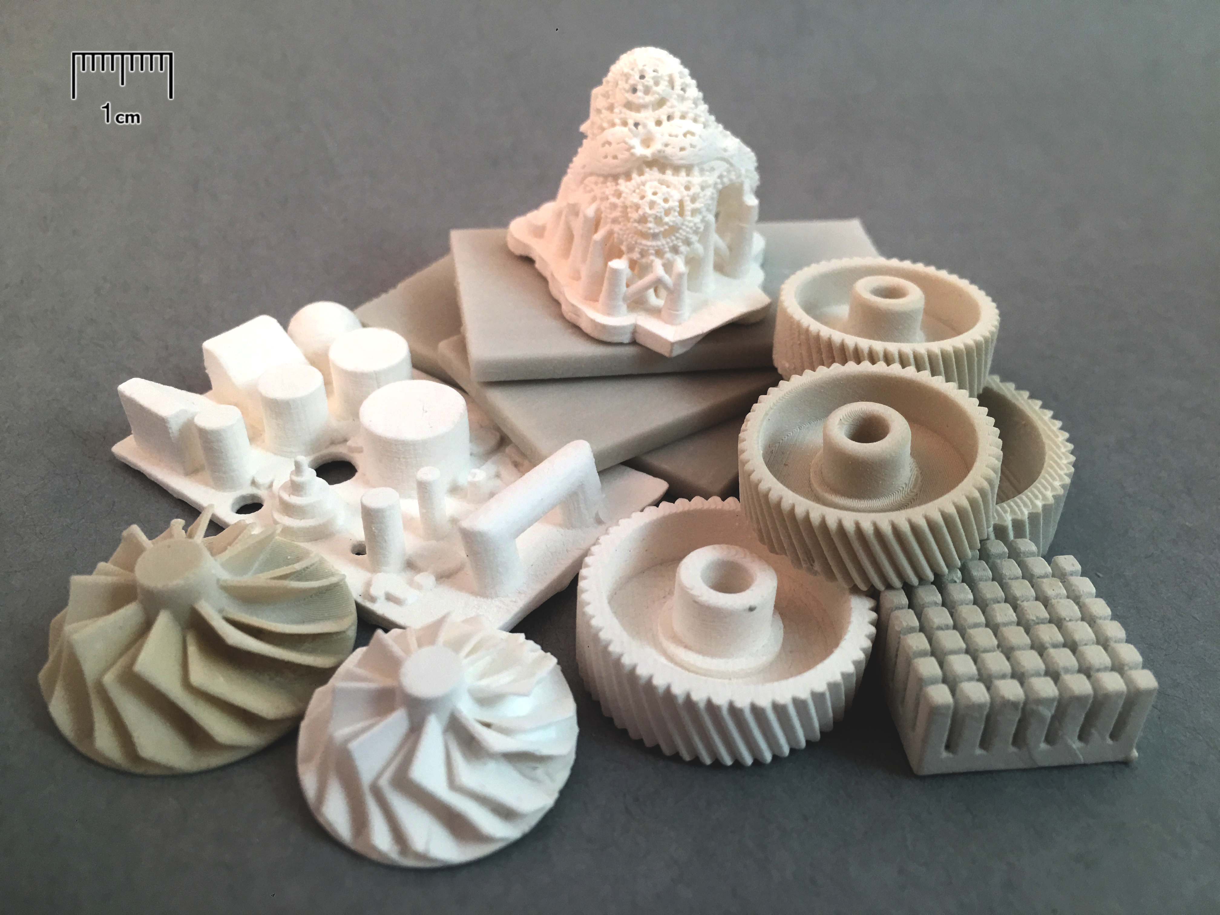

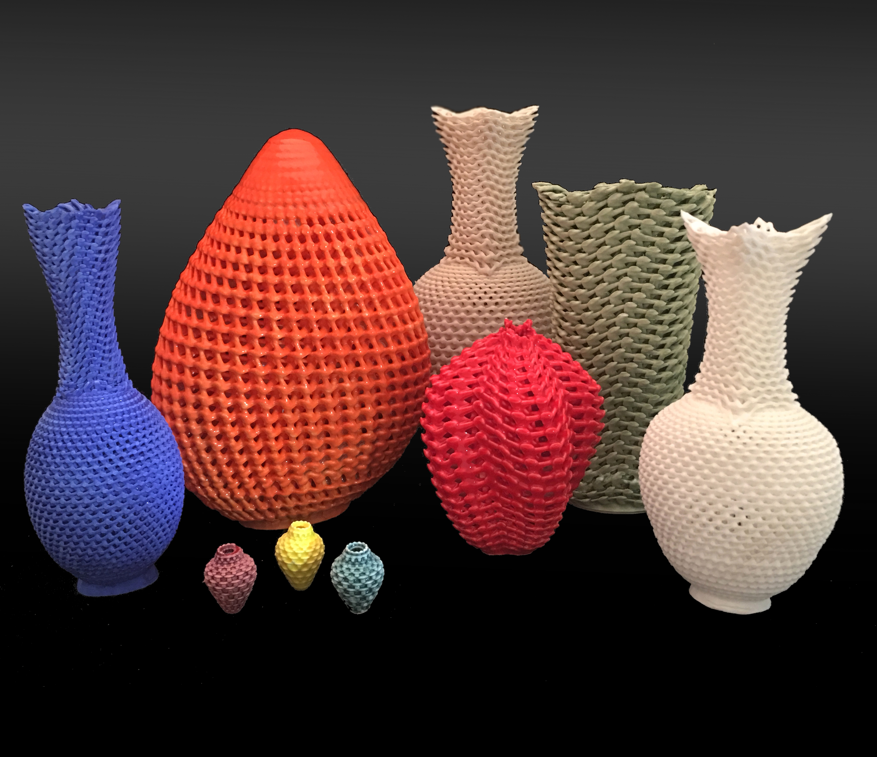
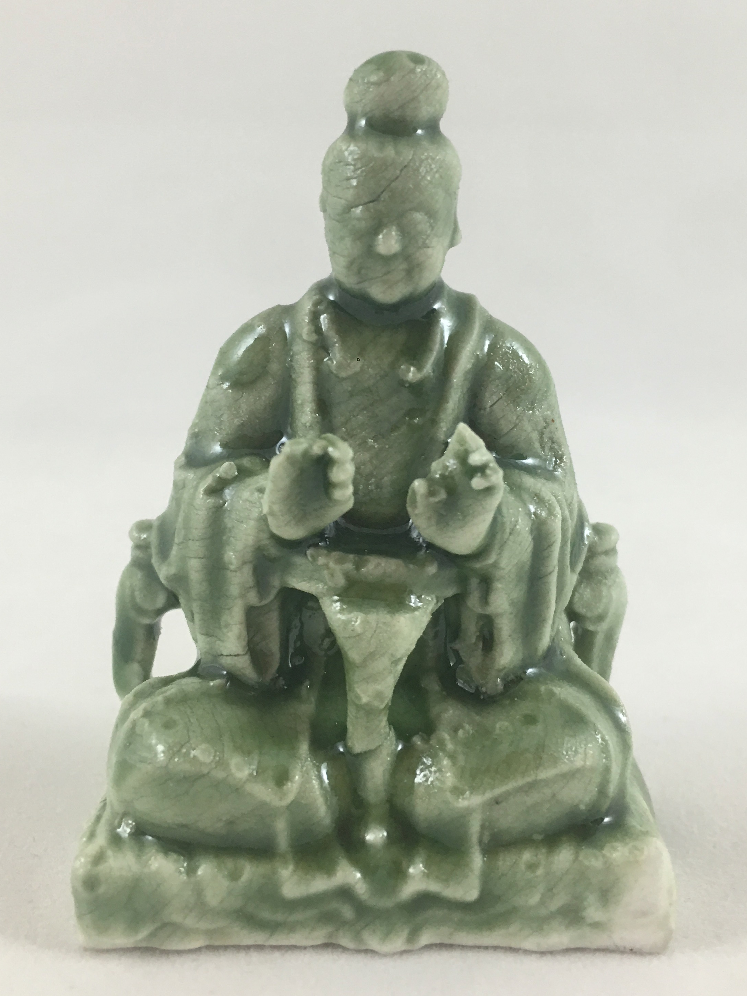
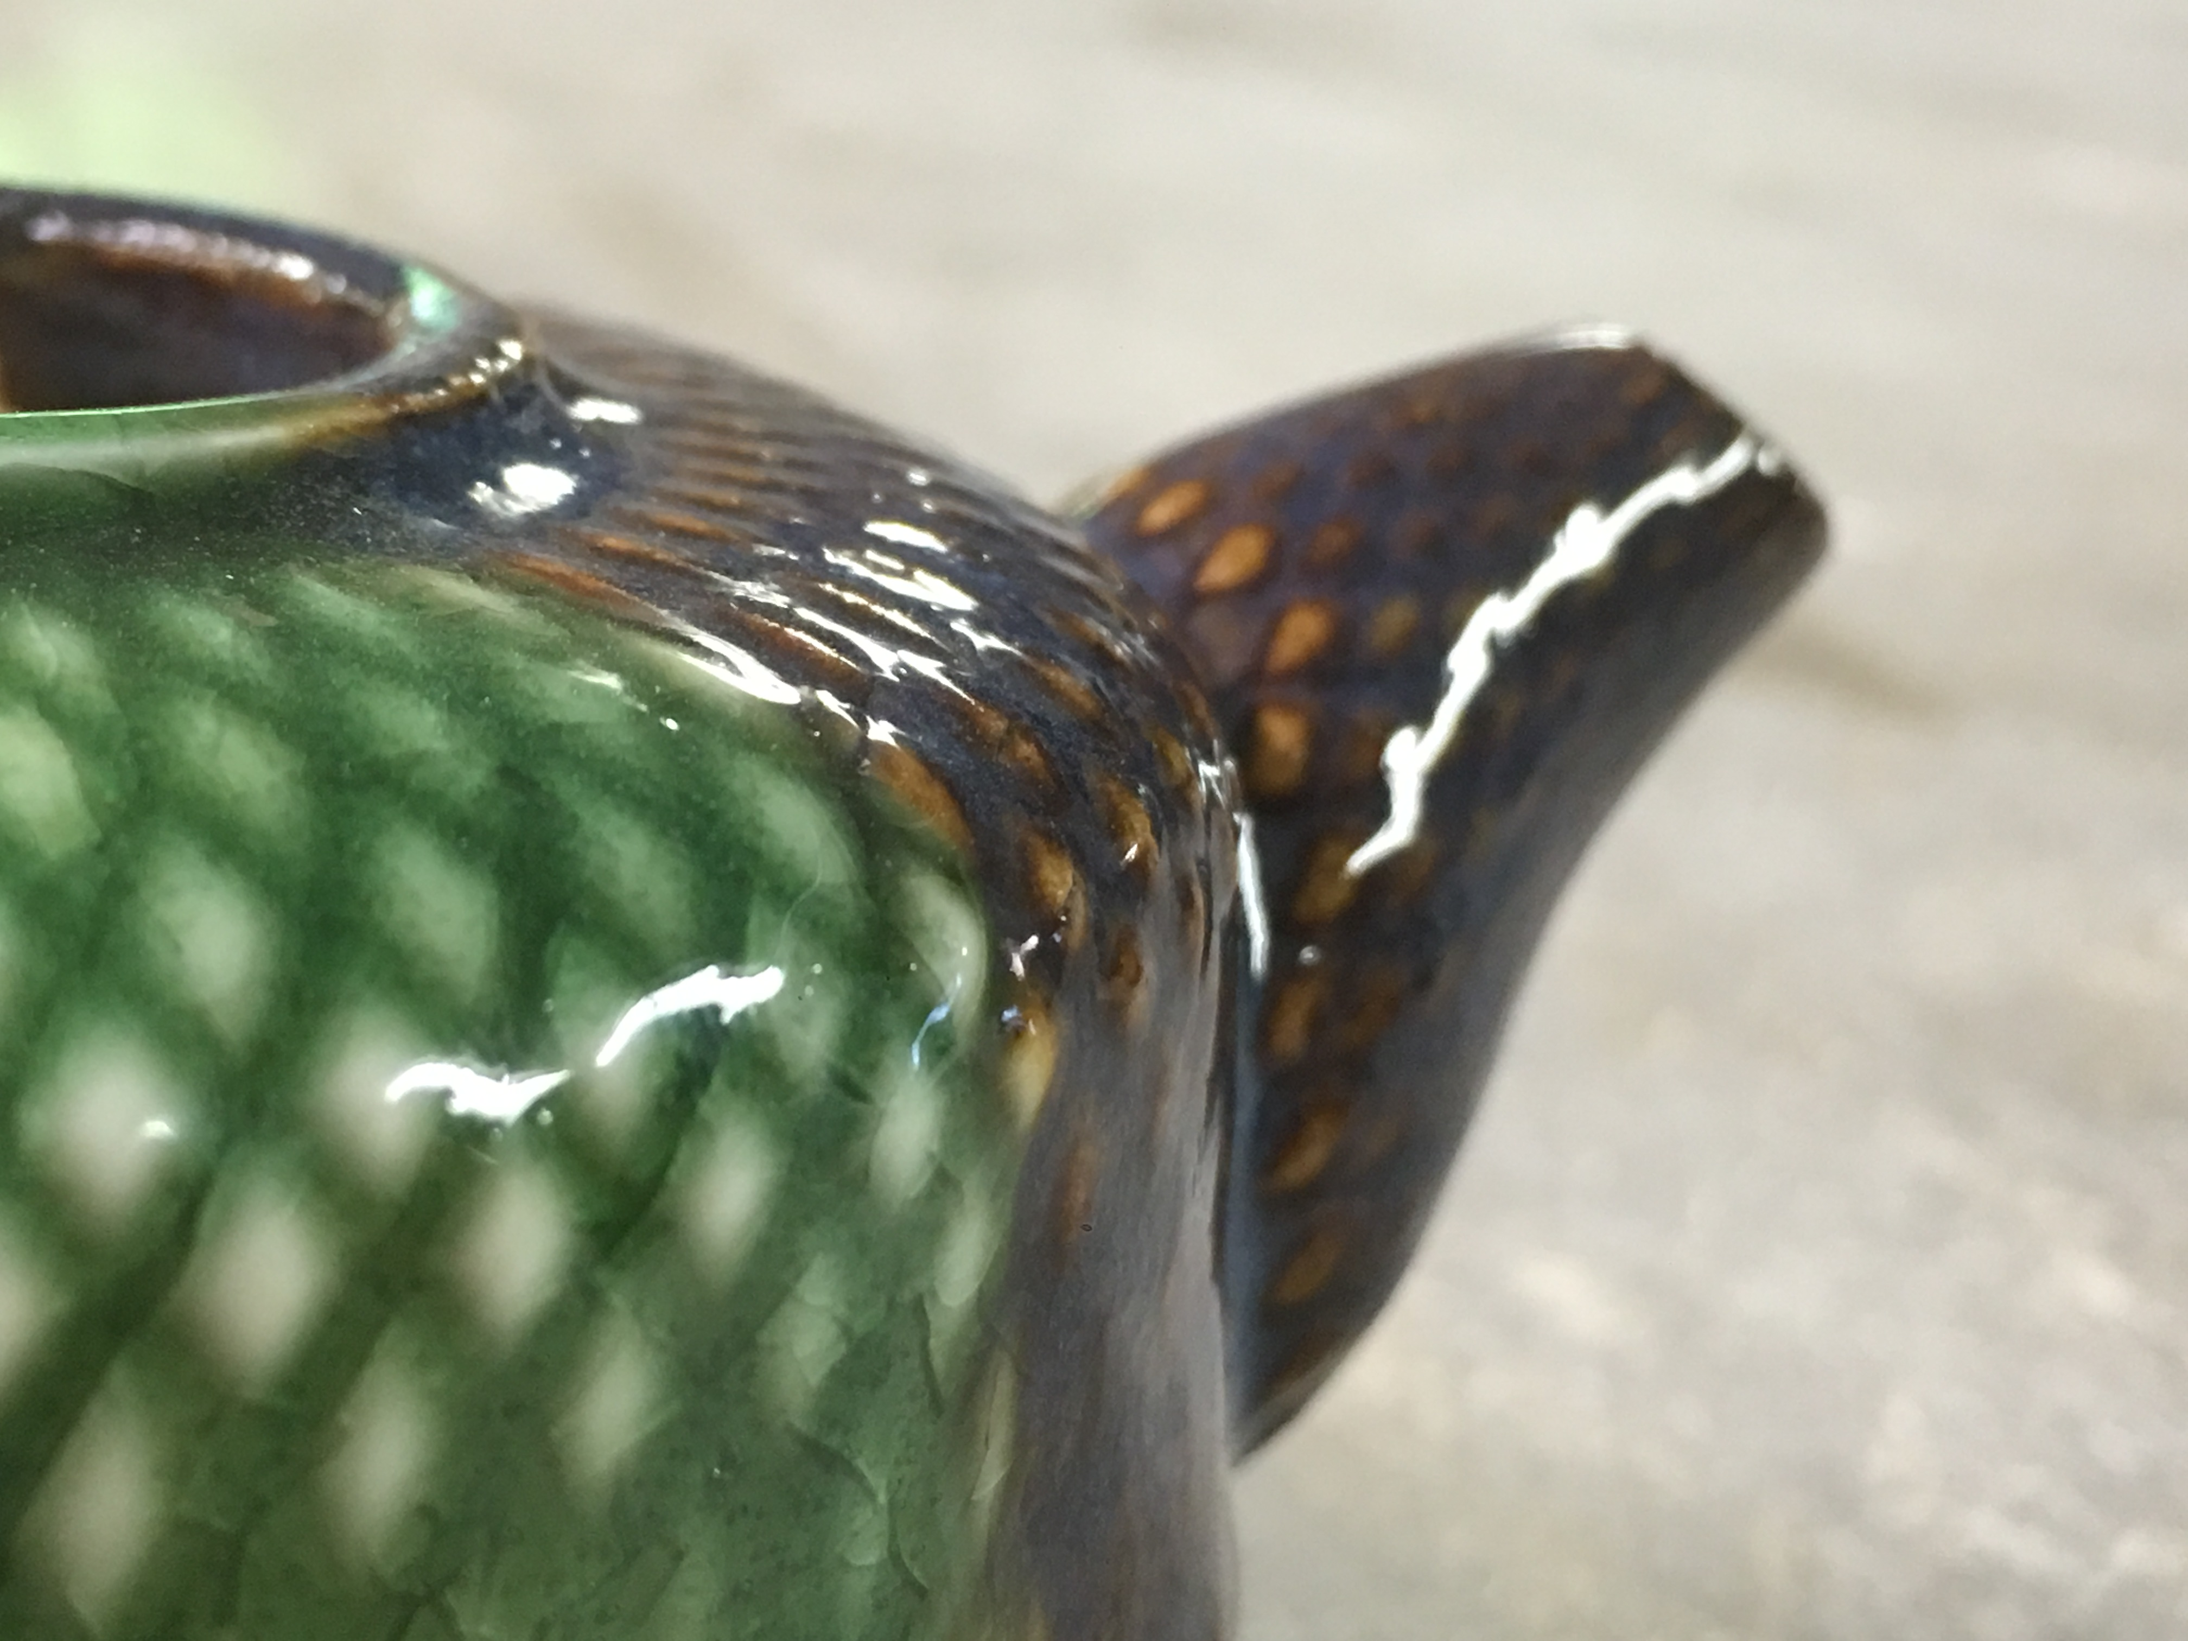
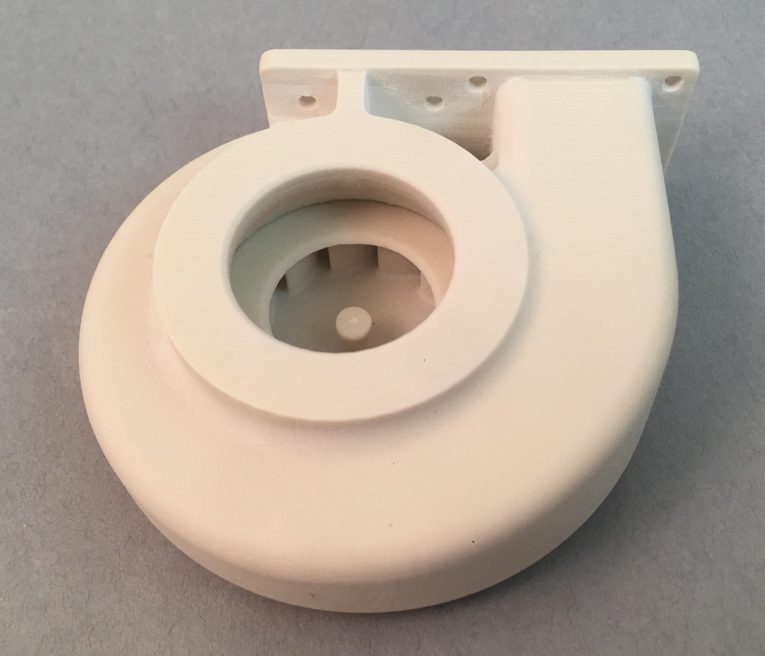
Realistic porcelain feel in green state is great for fast turn around ceramic prototypes
Functional Prototypes
Historical Artifact
Complex Geometry - Amazing detail
Heat Resistant _
Uses for Porcelite
Technical Ceramic Parts

Porcelite®

